Y3/4 YEAR A |  | Autumn |  | Spring |  | Summer
Core Texts | Narrative | 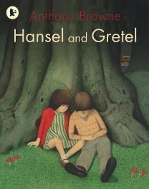  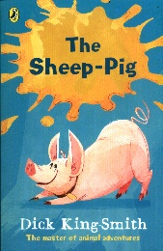  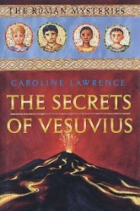 |  | 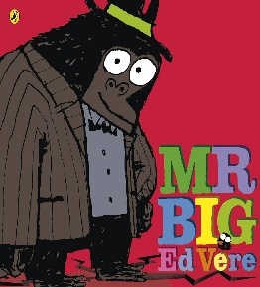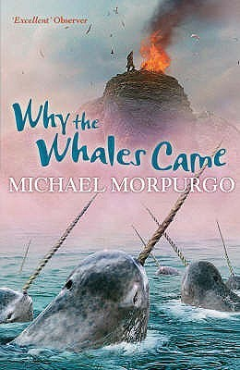 |  | 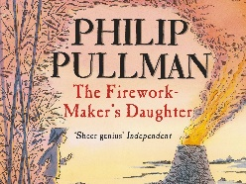  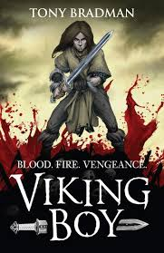
Core Texts | Non-Fiction | Recounts |  | Persuasive Texts |  | Explanations
Core Texts | Poetry | Chocolate Cake by Michael Rosen |  |  |  | Selfies with Komodos Brain Moses  The Bed Book Sylvia Plath
Core Texts | T4W Texts | Fiction: A Close Call (defeating monster tale)  Non-Fiction: Curious Creature Captured (recount) |  | Fiction: Mr Big (change tale)  Non-Fiction: Perfect Parrot for Sale (Persuasion) |  | Fiction: The Canal (Warning Tale)  Non-Fiction: Why You Should Not go into the Forest (Explanation)
Skills coverage for both year groups |  | Vocabulary  Retrieval |  | Vocabulary  Retrieval  Inference  Explaining |  | Vocabulary  Retrieval  Prediction  Inference  Explaining  Summarising
Ongoing word reading |  | At the beginning of Y3, all children who did not achieve the expected level in the PSC at the end of Y2 must continue with a programme of structured, synthetic phonics to fill the gaps and meet the expectation. Books given to them need to match their phonic ability closely with 95-98 accuracy to ensure fluency.  By the beginning of year 3, pupils should be able to read books written at an age-appropriate interest level, these will be assigned by reading age. They should be able to read them accurately and at a speed that is sufficient for  them to focus on understanding what they read rather than on decoding individual words.  Children will also have access to a reading for pleasure book which they can share with parents at home.  Children should be developing their knowledge and skills in reading non-fiction about a wide range of subjects. They should be learning to justify their views about what they have read: increasingly independently by the end of  year 4  At this stage, teaching comprehension should be taking precedence over teaching word reading directly. Any focus on word reading should support the development of vocabulary, except in the case of pupils who did not meet the PSC at the end of Y2 and for whom SSP will still be a priority.  The focus should continue to be on pupils’ comprehension as a primary element in reading. The knowledge and skills that pupils need in order to comprehend are very similar at different ages. This is why the programmes of study for comprehension in years 3 and 4 and years 5 and 6 are similar: the complexity of the writing increases the level of challenge.
 |  | Year 3/4 Autumn Term |  |  |  |  |  | Teaching for Fluency  Strategies
 |  | Year 3 |  |  | Year 4 |  |  | Teaching for Fluency  Strategies
 |  | Key Reading Skills | Question stems |  | Key Reading Skills |  | Question Stems | Teaching for Fluency  Strategies
Narrative  (6 weeks inc. 2 weeks on T4W text) |  | Vocabulary  - Use dictionaries to check the meaning of words that they have read  - Discuss words that capture the readers interest or imagination  - Identify how language choices help build meaning  - Find the meaning of new words using substitution within a sentence.  Retrieval  - Use contents page and subheadings to locate information  - Learn the skill of ‘skim and scan’ to retrieve details.  - Begin to use quotations from the text.  - Retrieve and record information from a fiction text.  - Retrieve information from a non-fiction text | Vocabulary  - What does this word/phrase/sentence tell you  - about the character/setting/mood?  - Can you find this word in the dictionary?  - By writing in this way, what effect has the author  - created?  - What other words/phrases could the author have used here?  - How has the author made you feel by writing...?  - Which word tells you that…?  - Find and highlight the word that is closest in meaning to…?  Retrieval  - Who are the characters in this text?  - When / where is this story set? How do you know?  - Which part of the story best describes the setting?  - What do you think is happening here?  - What might this mean?  - How might I find the information quickly?  - What can I use to help me navigate this book?  - How would you describe the story?  - Whose perspective is the story told from? |  | Vocabulary  - Using dictionaries to check the meaning of words that they have read  - Use a thesaurus to find synonyms  - Discuss why words have been chosen and the effect these have on the reader  - Explain how words can capture the interest of the reader  - Discuss new and unusual vocabulary and clarify the meaning of these  - Find the meaning of new words using the context of the sentence.  Retrieval  - Confidently skim and scan texts to record details,  - Using relevant quotes to support their answers to questions.  - Retrieve and record information from a fiction or non-fiction text. |  | Vocabulary  - Can you find the meaning or a word with a similar meaning in a dictionary or thesaurus?  - What does this word/phrase/sentence tell you about the character/setting/mood?  - By writing..., what effect has the author created?  - Do you think they intended to?  - What other words/phrases could the author have used here? Why? How has the author…?  - Which word is closest in meaning to…?  Retrieval  - Find the... in this text. Is it anywhere else?  - When/where is this story set? How do you know?  - Find the part of the story that best describes the setting.  - What do you think is happening here? Why?  - What might this mean?  - Whose perspective is the story told by and how do you know?  - How can you use the subheading to help you here? | Choral reading  Marking up the text  Echo Reading  Guided oral reading  Repeated reading
Non-Fiction  (Recount)  (5 weeks inc. 2 weeks on T4W text) |  | - Learn the skill of ‘skim and scan’ to retrieve details.  - Retrieves and records information from non-fiction using contents, index and glossary.  - Can identify key organisational features of different text types.  - Can identify keywords for locating information from the text. E.g using headings. |  |  | - Ask relevant questions to further enhance their understanding of the text.  - Retrieves and records information from non-fiction presenting their findings in their own words.  - Can scan for keywords in text and questions.  - Identifies themes and conventions in a wide range of books. |  |  | Choral reading  Marking up the text  Echo Reading  Guided oral reading  Repeated reading
Poetry  (2 weeks) |  | - Predicting what might happen from details stated and implied explaining their reasoning.  - Increasing their familiarity with a wide range of books, including fairy stories, myths and legends, and retelling some of these orally  - Has learnt and can recite familiar poems and stories  - Use inference skills to interpret poems |  |  | - use relevant prior knowledge as well as details from the text to form predictions and to justify them.  - Infer characters’ feelings, thoughts and motives from their stated actions.  - Performance poems with tone, intonation and action  - To retrieve information from different forms of poetry.  - Use inference skills to interpret poems |  |  | Choral reading  Marking up the text  Echo Reading  Guided oral reading  Repeated reading  Reader’s Theatre
 |  | Year 3/4 Spring Term |  |  |  |  |  | Teaching for Fluency  Strategies
 |  | Year 3 |  |  | Year 4 |  |  | Teaching for Fluency  Strategies
 |  | Key Reading Skills | Question Stems |  | Key Reading Skills |  | Question Stems | Teaching for Fluency  Strategies
Narrative  (7 weeks inc.  2 weeks on T4W text) |  | Explaining  - Discussing the features of a wide range of fiction, poetry, plays, non-fiction and reference books  - Identifying how language, structure, and presentation contribute to meaning of both fiction and non-fiction texts  - Recognise authorial choices and the purpose of these  Inference  - Children can infer characters’ feelings, thoughts and motives from their stated actions.  - Justify inferences by referencing a specific point in the text.  - Ask and answer questions appropriately, including some simple inference questions based on characters’ feelings, thoughts and motives.  - Make inferences about actions or events | Explaining  - What is similar/different about two characters?  - Explain why... did that.  - Describe different characters’ reactions to the same event.  - Is this as good as...?  - Which is better and why?  - Why do you think they chose to order the text in this way?  - What is the purpose of this text and who do you think it was written for?  - What is the author’s viewpoint? How do you know?  - How are these two sections in the text linked?  Inference  - What do you think.... means?  - Why do you think that?  - Why do you think...?  - How do you think....?  - Can you explain why....?  - What do these words mean and why do you think that the author chose them?  - Find and copy a group of words which show…?  - How does the description of … show that they are…?  - Who is telling the story?  - Why has the character done this at this time? |  | Explaining  - Discussing words and phrases that capture the reader’s interest and imagination  - Identifying how language, structure, and presentation contribute to meaning  - Recognise authorial choices and the purpose of these  Inference  - Ask and answer questions appropriately, including some simple inference questions based on characters’ feelings, thoughts and motives (I know this because questions)  - Infer characters’ feelings, thoughts and motives from their stated actions.  - Consolidate the skill of justifying them using a specific reference point in the text  - Use more than one piece of evidence to justify their answer |  | Explaining  - What is similar/different about two characters?  - Did the author intend that?  - Explain why... did that.  - Describe different characters’ reactions to the same event.  - Is this as good as...?  - Which is better and why?  - What can you tell me about how this text is organised?  - Why is the text arranged in this way?  - What is the purpose of this text and who is the audience?  - How does the author engage the reader here?  Inference  - What do you think.... means?  - Why do you think that? Could it be anything else?  - I think....; do you agree? Why / why not?  - How do you think....?  - Can you explain why....?  - Can you explain why based on two different pieces  - of evidence?  - What do these words mean and why do you think that the author chose them?  - Find and copy a group of words which show that…  - What impression of …do you get from this paragraph? | Choral reading  Marking up the text  Echo Reading  Guided oral reading  Repeated reading
Non-Fiction  (Persuasion)  (5 weeks inc. 2 weeks on T4W text) |  | - Learn the skill of ‘skim and scan’ to retrieve details.  - Retrieves and records information from non-fiction using contents, index and glossary.  - Can identify key organisational features of different text types.  - Can identify keywords for locating information from the text. E.g using headings. |  |  | - Ask relevant questions to further enhance their understanding of the text.  - Retrieves and records information from non-fiction presenting their findings in their own words.  - Can scan for keywords in text and questions.  - Identifies themes and conventions in a wide range of books. |  |  | Choral reading  Marking up the text  Echo Reading  Guided oral reading  Repeated reading
 |  | Year 3/4 Summer Term |  |  |  |  |  | Teaching for Fluency  Strategies
 |  | Year 3 |  |  | Year 4 |  |  | Teaching for Fluency  Strategies
 |  | Key Reading Skills | Question Stems |  | Key Reading Skills |  | Question Stems | Teaching for Fluency  Strategies
Narrative  (5 weeks inc.  2 weeks on T4W text) |  | Summarise  - Identifying main ideas drawn from a key paragraph or page and summarising these  - Begin to distinguish between the important and  less important information in a text.  - Give a brief verbal summary of a story.  - Teachers begin to model how to record summary writing.  - Identify themes from a wide range of books  - Make simple notes from one source of writing  Prediction  - Justify predictions using evidence from the text.  - Use relevant prior knowledge to make predictions and justify them.  - Use details from the text to form further predictions. | Summarise  - What is the main point in this paragraph?  - Sum up what has happened so far in X words or less.  - Which is the most important point in these paragraphs?  - Do any sections/paragraphs deal with the same themes?  - Have you noticed any similarities between this text and any others you have read?  - What do I need to jot down to remember what I have read?  Prediction  - Can you think of another story with a similar theme?  - Which stories have openings like this?  - Do you think that this story will develop the same way?  - Why did the author choose this setting? Will that influence the story?  - What happened before this and what do you think will happen after?  - Do you think the setting will have an impact on plot moving forward? |  | Summarise  - Use skills developed in year 3 in order to write a  - brief summary of main points, identifying and using important information.  - Identifying main ideas drawn from more than one paragraph.  - Identify themes from a wide range of books  - Summarise whole paragraphs, chapters or texts  - Highlight key information and record it in bullet points, diagrams, maps etc  Prediction  - Justify predictions using evidence from the text.  - Use relevant prior knowledge as well as details from the text to form predictions and to justify them.  - Monitor these predictions and compare them with the text as they read on |  | Summarise  - What is the main point in this paragraph? Is it  mentioned anywhere else?  - Sum up what has happened so far in X words/seconds or less.  - Which is the most important point in these paragraphs? Why?  - Do any sections/paragraphs deal with the same themes?  - How might I record this to ensure the best possible outcome?  Prediction  - Can you think of another text with a similar theme? How do their plots differ?  - Which stories have openings like this? Do you think that this story will develop the same way?  - Why did the author choose this setting? Will that influence the story?  - What does this paragraph suggest what will happen next?  - Do you think … will happen? Explain your answers with evidence from the text. | Choral reading  Marking up the text  Echo Reading  Guided oral reading  Repeated reading
Non-Fiction  (Explanation)  (5 weeks inc.  2 weeks on T4W text) |  | - Learn the skill of ‘skim and scan’ to retrieve details.  - Retrieves and records information from non-fiction using contents, index and glossary.  - Can identify key organisational features of different text types.  - Can identify keywords for locating information from the text. E.g using headings. |  |  | - Ask relevant questions to further enhance their understanding of the text.  - Retrieves and records information from non-fiction presenting their findings in their own words.  - Can scan for keywords in text and questions.  - Identifies themes and conventions in a wide range of books. |  |  | Choral reading  Marking up the text  Echo Reading  Guided oral reading  Repeated reading
Poetry  (2 weeks) |  | - Predicting what might happen from details stated and implied explaining their reasoning.  - Increasing their familiarity with a wide range of books, including fairy stories, myths and legends, and retelling some of these orally  - Has learnt and can recite familiar poems and stories  - Use inference skills to interpret poems |  |  | - use relevant prior knowledge as well as details from the text to form predictions and to justify them.  - Infer characters’ feelings, thoughts and motives from their stated actions.  - Performance poems with tone, intonation and action  - To retrieve information from different forms of poetry.  - Use inference skills to interpret poems |  |  | Choral reading  Marking up the text  Echo Reading  Guided oral reading  Repeated reading  Reader’s Theatre

