Osgodby Primary School
Calculation Policy
September 2022

Early Years Foundation Stage Calculations: F1
Foundation Stage: F1
Before addition can be introduced, children need to have a secure knowledge of number. In F1, children are introduced to the concept of counting, number order and number recognition through practical activities and games.
This is taught through child initiated games, such as hide and seek and I spy. Children also learn how to count 1-1 (pointing to each object as they count) and that anything can be counted, for example, claps, steps and jumps. This is reinforced by opportunities provided in the outdoor area for the children to count e.g. counting building blocks, twigs etc.
Introduction to addition:
Once children are secure in their number knowledge, children are introduced to the concept of more and less. Children learn how to distinguish the difference between sets of objects and when two groups are of the same size. Adults model the initial addition vocabulary supported by age appropriate definition. An example of this is
“This group has more, this group has less. These groups have the same. They are equal”

Children are taught all number objectives within the 30-50 month age band from the Development Matters curriculum beginning to extend into 40-60 months. Children are then given opportunities to transfer adult taught skills during independent play. This is supported by the three Characteristics of Effective Learning: playing and exploring, active learning, creating and thinking critically

Before subtraction can be introduced, children need to have a secure knowledge of number. In F1, children are introduced to the concept of counting backwards. This is taught through child initiated games indoors and outdoors such as acting out counting songs and running races (children shouting “5,4,3,2,1,0 - GO!”).

Introduction to subtraction:
Once children are secure in their number knowledge, children are introduced to the concept of less and subtracting by counting backwards. Children learn how to take 1 object away through singing songs such as ‘5 little monkeys’. Children use their fingers to represent how many monkeys are left with adults modelling how to ‘subtract’ one finger / monkey away each time.
Adults model the initial subtraction vocabulary supported by age appropriate definition. An example of this is
“subtract / take away, we have one less monkey, OH NO! One monkey has gone away!”

Children are taught all number objectives within the 30-50 month age band from the Development Matters curriculum beginning to extend to 40-60 months.. Children are then given opportunities to transfer adult taught skills during independent play. This is supported by the three characteristics of effective learning: playing and exploring, active learning, creating and thinking critically
Doubling
Doubling and halving is not expected in F1, however the concepts can be introduced through discussion and play if appropriate.
Before doubling can be introduced, children need to have a secure knowledge of counting, number facts and addition in order to double.
Children are then introduced to the concept of doubling through practical games and activities, including the use of the outdoor areas. Children act out ‘doubling’ by physically adding two equal groups together to find out the ‘doubles’ answer.
What is double 2? Double 2 equals 4
Children build on their previous knowledge of ‘addition’ by learning that doubling is when you add two equal amounts together.
Double 2 is 4! That means that 2 add 2 equals 4, 2 times 2 equals 4.

Halving
Before halving can be introduced, children need to have a secure knowledge of counting forwards and backwards, number facts and subtraction in order to halve and share.
Children are then introduced to the concept of halving and sharing through practical games and activities. They act out ‘halving and sharing’ through activities such as sharing food for their Teddy Bear’s Picnic, sharing resources equally to play a game. This is reinforced by opportunities provided in the outdoor area for the children to halve and share out objects such as building blocks, twigs etc.

Children build on their previous knowledge of ‘subtraction’ by learning that halving and sharing is when you divide an amount into equal groups.
Adults model halving, sharing and initial division vocabulary supported by age appropriate definition. An example of this is
One for you, one for me…! How many have you got? (Adults to model counting to check) We have got the 3 same. You have got 3 cakes and I have got cakes

Foundation Stage: F2
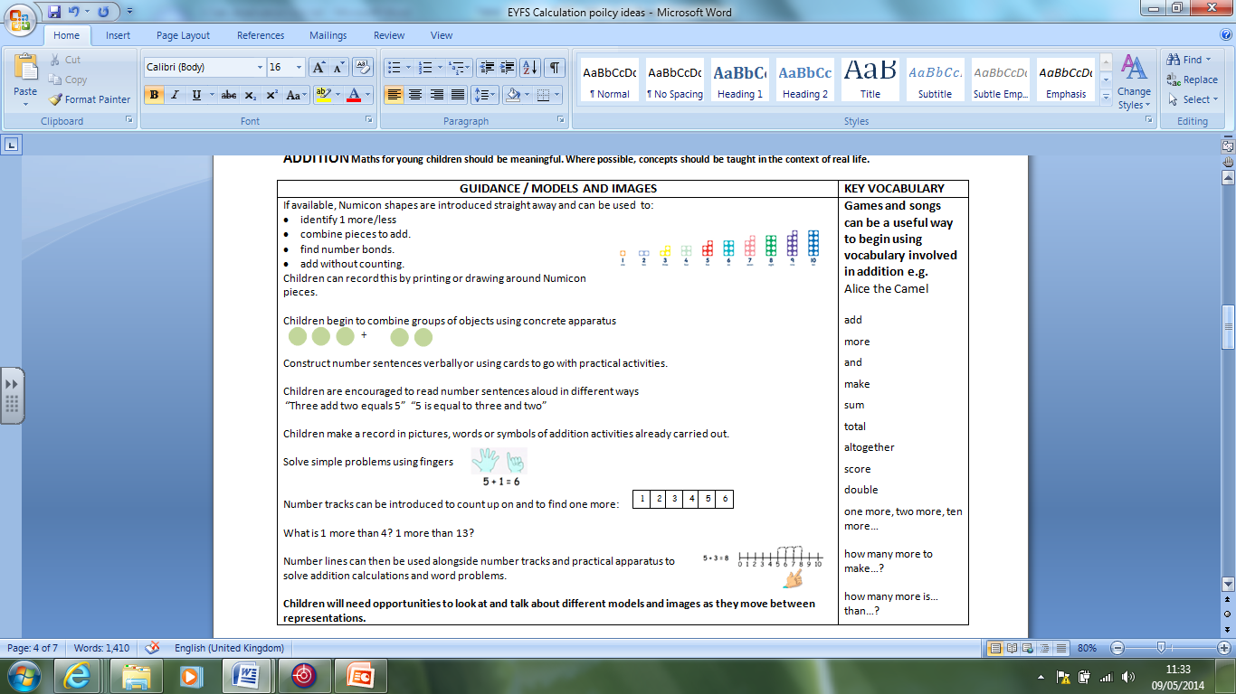
Early Years Foundation Stage: Addition
Introduce + = (equal to or same as)

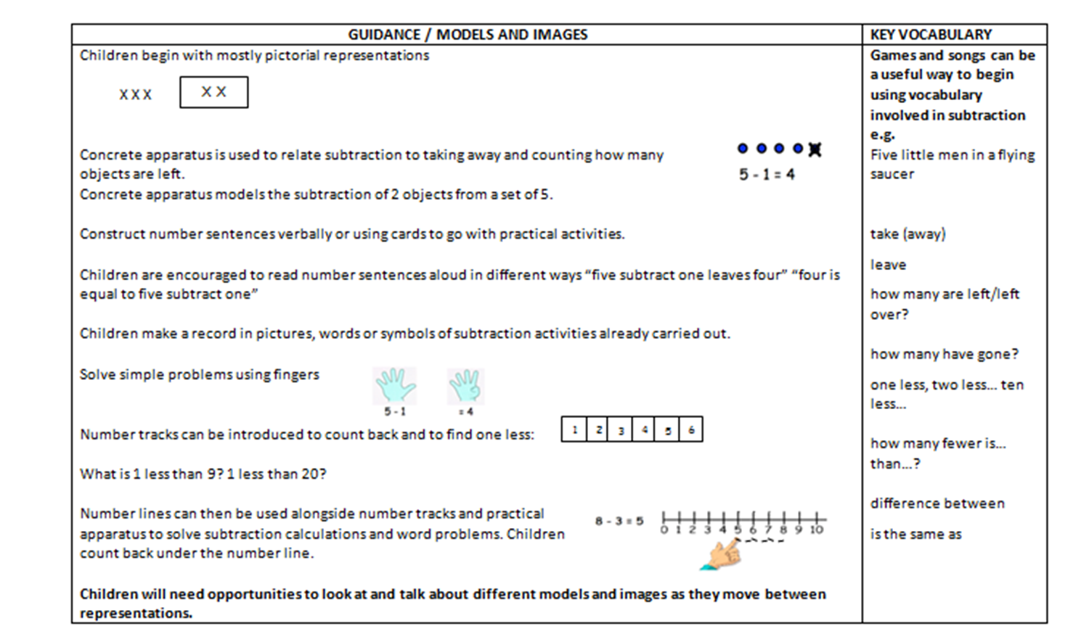
Early Years Foundation Stage: Subtraction
Introduce – to mean take away and = as equals and is the same as
XX
XXX take away 2 X = 1

Section 3: Development Matters in the Early Years Foundation Stage (EYFS)
This non-statutory guidance material supports practitioners in implementing the statutory requirements of the EYFS.
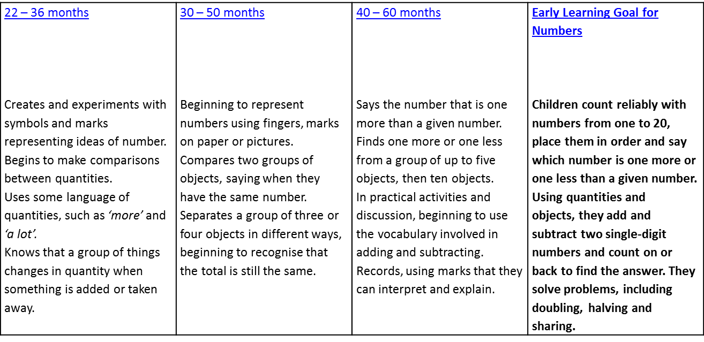

The importance of language development in FS mathematics
The sequential development of a childs language and vocabulary has a direct effect on their ability to explain their understanding to others. In terms of mathematical calculations a child also has to develop subject specific vocabulary alongside the development of their understanding of calculation concepts. These include:

Recite number names in sequence ( 22-36 months)
Uses number names and number language spontaneously (30-50months)
Uses some number names accurately in play (30-50 months)
Recites numbers in order to 10 (30-50 months)

Year 1 - Addition
Mental Strategies | Written Method
- Children should experience regular counting on and back from different numbers in 1s and in multiples of 2, 5 and 10.  - Children should memorise and reason with number bonds for numbers to 20, experiencing the = sign in different positions.  - They should see addition and subtraction as related operations. E.G 7 + 3 = 10 is related to 10 – 3 = 7.  - Use bundles of straws to model partitioning teen numbers into tens and ones and develop understanding of place value.  - Children should begin to understand addition as combining groups and counting on. | + = signs and missing numbers  Children need to understand the concept of equality before using the ‘=’ sign. Calculations should be written either side of the equality sign so that the sign is not just interpreted as ‘the answer’.  2 = 1+ 1  2 + 3 = 4 + 1  Use weighing pans/balances to explore this.  Missing numbers need to be placed in all possible places.  3 + 4 = = 3 + 4  3 + = 7 7 = + 4  Children have opportunities to explore partitioning numbers in different ways. e.g. 7 = 6 + 1, 7 = 5 + 2, 7 = 4 + 3 =  Counting and Combining sets of Objects  Combining two sets of objects (aggregation) which will progress onto adding on to a set (augmentation)  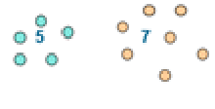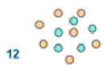  Understanding of counting on with a number track.  Understanding of counting on with a number line (supported by models and images).  7+ 4  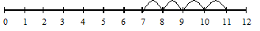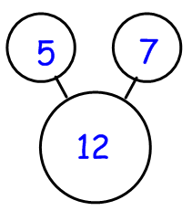Part Part Whole
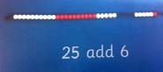
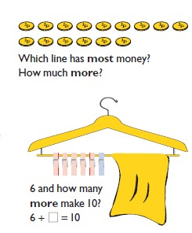
Children’s Representations
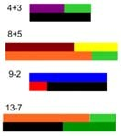
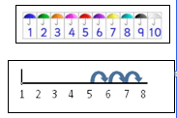
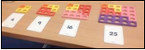
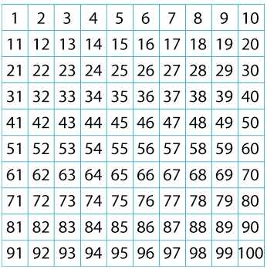
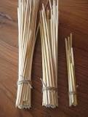
Use of 100 square for counting and addition.

Year 1 - Addition
Key Vocabulary
Addition, add, forwards, put together, more than, total, altogether, distance, between, difference between, equals = same as, most pattern, odd, even digit, counting on.

Key Questions and Generalisations  True or false? Addition makes numbers bigger.  True or false? You can add numbers in any order and still get the same answer.  (Links between addition and subtraction)  When introduced to the equals sign, children should see it as signifying equality. They should become used to seeing it in different positions.  How many altogether? How many more to make…? I add 3 more..? What is the total? How many more is…than…? How much more is…? One more, two more, ten more…  What can you see here?  Is this true or false?  What is the same? What is different?  Links from other curriculum areas:  Combine and increase numbers, counting forwards and backwards.  Develop the concept of addition and subtraction and … use these operations flexibly.  Discuss and solve problems in familiar practical contexts, including using quantities.  Compare, describe and solve practical (measure) problems e.g. longer, more than, heavier than  Problem terminology should include: put together, add, altogether, total, take away, distance between, difference between, more than and less than, is the same as. | Mastery  Use the pattern to complete the number sentences.  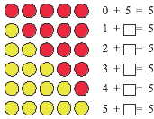  Now do the same for rows of 6 counters, 7 counters, 8 counters, 9 counters and 10 counters.  Children should be able to recall all number bonds to and within 10. Exposing the structure of the mathematics supports this process. They should then apply this to number bonds to 20, so if 5+3 = 8, 15 +3 = 18  I’m thinking of? Explain how you know.  I’m thinking of a number. I’ve added 8 and the answer is 19. What number was I thinking of? Explain how you know.  I know that 7 and 3 is 10. How can I find 8 + 3? How could you work it out? Show children a price list with items costing up to 20p.  I have 20p to spend. If I spend 20p exactly, which two items could I buy? And another two, and another two.  If I bought one of the items how much change would I have? And another one, and another one.
Year 2 - Addition
Mental Strategies | Written Method
Children should count regularly, on and back, in steps of 2, 3, 5 and 10. Counting forwards in tens from any number should lead to adding multiples of 10.  Number lines should continue to be an important image to support mathematical thinking, for example to model how to add 9 by adding 10 and adjusting.  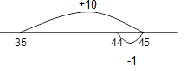  Children should practise addition to 20 to become increasingly fluent. They should use the facts they know to derive others, e.g using 7 + 3 = 10 to find 17 + 3= 20, 70 + 30 = 100  They should use concrete objects such as bead strings and number lines to explore missing numbers 45 + __ = 50.  As well as number lines, 100 squares could be used to explore patterns in calculations such as 74 +11, 77 + 9 encouraging children to think about ‘What do you notice?’ where partitioning or adjusting is used.  Children should learn to check their calculations, by using the inverse.  They should continue to see addition as both combining groups and counting on.  They should use Dienes to model partitioning into tens and ones and learn to partition numbers in different ways e.g. 23 = 20 + 3 = 10 + 13 | Missing number problems e.g 14 + 5 = 10 + 32 + + = 100 35 = 1 + + 5  It is valuable to use a range of representations (also see Y1). Continue to use numberlines to develop understanding of:  Counting on in tens and ones  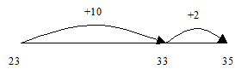  23 + 12 = 23 + 10 + 2  = 33 + 2  = 35  Partitioning and bridging through 10.  The steps in addition often bridge through a multiple of 10  e.g. Children should be able to partition the 7 to relate adding the 2 and then the 5.  8 + 7 = 15 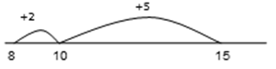  Adding 9 or 11 by adding 10 and adjusting by 1  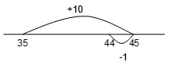  e.g. Add 9 by adding 10 and adjusting by 1  35 + 9 = 44  Partitioning in different ways and recombine  47+25  47 25 60 + 12  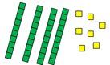  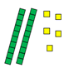  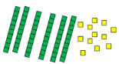  Leading to exchanging: 72  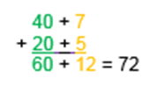  Expanded written method  40 + 7 + 20 + 5 =  40+20 + 7 + 5 =  60 + 12 = 72  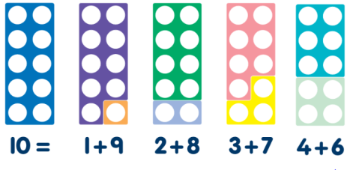  Using Numicon to support addition.
Key Vocabulary
add, addition, more, plus, make, sum, total, altogether, how many more to make…? how many more is… than…? how much more is…? =, equals, sign, is the same as, Tens, ones, partition, near multiple of 10, tens boundary, More than, one more, two more… ten more… one hundred more

Year 2 - Addition  Key Questions and Generalisations  Noticing what happens when you count in tens (the digits in the ones column stay the same)  • Odd + odd = even; odd + even = odd; etc  • show that addition of two numbers can be done in any order (commutative) and subtraction of one number from another cannot  • Recognise and use the inverse relationship between addition and subtraction and use this to check calculations and missing number problems. This understanding could be supported by images such as this.  How many altogether? How many more to make…? How many more is… than…? How much more is…?  Is this true or false?  If I know that 17 + 2 = 19, what else do I know? (e.g. 2 + 17 = 19; 19 – 17 = 2; 19 – 2 = 17; 190 – 20 = 170 etc).  What do you notice? What patterns can you see?  Links from other curriculum areas:  Solve problems:  - Using concrete objects, pictorial representations (numbers, quantities & measures)  - Applying increasing knowledge of mental & written methods  - Partition numbers in different ways  - Discuss and solve problems that emphasise the value of each digit in two digit numbers  (They should) develop the concept of addition and subtraction and … use these operations flexibly.  (Number addition and subtraction, Non statutory guidance.) | Mastery  Fill in the missing numbers and explain what you notice.  23 + ? = 30 33 – ? = 30  43 + ? = 50 53 – 3 = ?  If each peg on the coat hanger has a value of 10, find three ways to partition the pegs to make the number sentences complete.  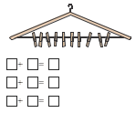  What is the total of each addition sentence?  Will the total always be the same?  Explain your reasoning.  ‘An odd number + an odd number = an even number’.  Explain your reasoning.  Concrete resources might help their reasoning.
Year 2 – Addition  Fractions  Counting in fractions up to 10, starting from any numbers using halves visually and on a number line  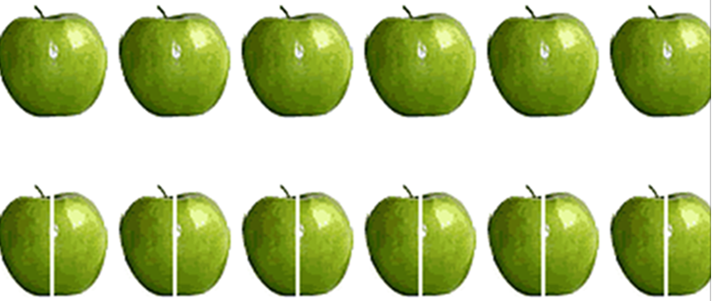  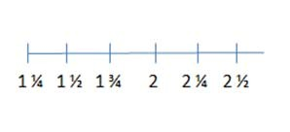 | Children’s Representations  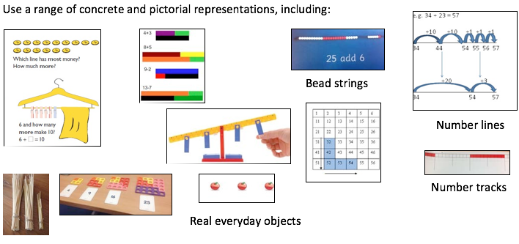  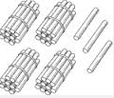  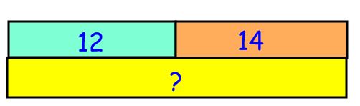  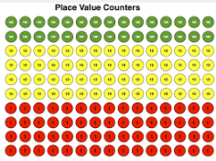  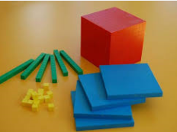

Year 3 – Addition
Mental Strategies |  | Written Method
Children should continue to count regularly, on and back, now including multiples of 4, 8, 50, and 100, and steps of 1/10.  The number line should continue to be used as an important image to support thinking, and the use of informal jottings should be encouraged. This will help to develop children’s understanding of working mentally.  Children should continue to partition numbers in different ways.  They should be encouraged to choose the mental strategies which are most efficient for the numbers involved, e.g.  Add the nearest multiple of 10, then adjust such as 63 + 29 is the same as 63 + 30 – 1;  counting on by partitioning the second number only such as 72 + 31 = 72 + 30 + 1 = 102 + 1 = 103  Manipulatives can be used to support mental imagery and conceptual understanding. Children need to be shown how these images are related eg.  What’s the same? What’s different?  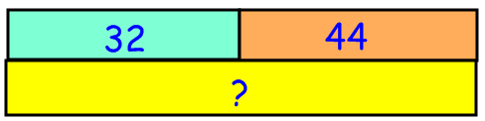  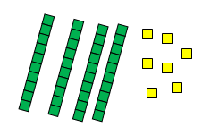  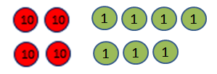 |  | Missing number problems using a range of equations as in Year 1 and 2 but with appropriate, larger numbers.  Partition into tens and ones  Partition both numbers and recombine.  Count on by partitioning the second number only e.g.  247 + 125 = 247 + 100 + 20+ 5 247 +125  = 347 + 20 + 5 = 200 + 40 +7 +100 + 20 + 5  = 367 + 5 = 200+100 +40 +20 + 7+5  = 372 =300 +60 +12 =372  Children need to be secure adding multiples of 100 and 10 to any three-digit number including those that are not multiples of 10.  Towards a Written Method  Introduce expanded column addition modelled with place value counters (Dienes could be used for those who need a less abstract representation)  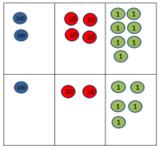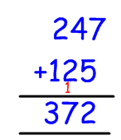  Leading to children understanding the exchange between tens and ones.  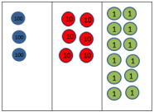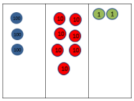  Some children may begin to use a formal columnar algorithm, initially introduced alongside the expanded method. The formal method should be seen as a more streamlined version of the expanded method, not a new method.
Year 3 – Addition  Key Questions and Generalisations  Noticing what happens to the digits when you count in tens and hundreds.  Odd + odd = even etc (see Year 2)  Inverses and related facts – develop fluency in finding related addition and subtraction facts.  Develop the knowledge that the inverse relationship can be used as a checking method.  What do you notice? What patterns can you see?  When comparing two methods alongside each other: What’s the same? What’s different? Look at this number in the formal method; can you see where it is in the expanded method / on the number line?  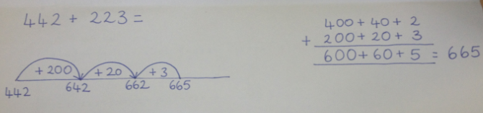  Links from other curriculum areas:  - Pupils should estimate the answers to a calculation and use inverse operations to check answers.  - Add amounts of money using both £ and p in practical contexts.  - Measure, compare and add lengths (m/cm/mm), mass (kg/g) and volume/capacity (l/ml) | Fractions  Addition of fractions with the same denominator within one whole.  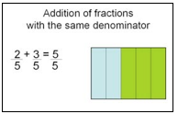 |  | Mastery  What do you notice?  Is there a relationship between the calculations?  500 + 400 = 523 + 400 = 523 + 28 =  400 + 500 = 423 + 500 = 423 + 28 =  300 + 600 = 323 + 600 = 323 + 28 =  200 + 700 = 223 + 700 = 223 + 28 =  100 + 800 = 123 + 800 = 123 + 48 =  Using coins, find three ways to make £1.  Flo and Jim are answering a problem:  Danny has read 62 pages of the class book, Jack has read 43. How many more pages has Danny read than Jack?  Flo does the calculation 62 + 43. Jim does the calculation 62–43. Who is correct?  Explain how you know.  Pupils might demonstrate using a bar model to explain their reasoning.  Sophie has five coins in her pocket. How much money might she have? What is the greatest amount she can have?  What is the least amount she can have?  If all the coins are different:  What is the greatest amount she can have? What is the least amount she can have?

Year 3 – Addition  Key Vocabulary  Hundreds, tens, ones, estimate, partition, recombine, difference, decrease, near multiple of 10 and 100, inverse, rounding, column subtraction, exchange  See also Y1 and Y2 | Children’s Representations  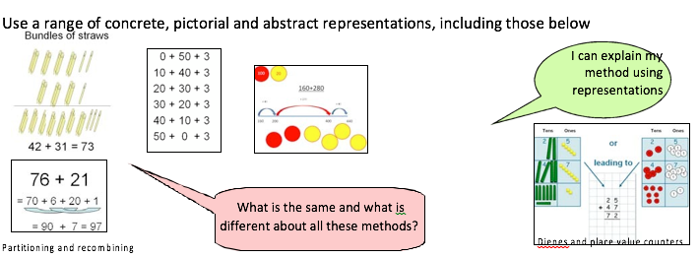

Year 4 – Addition
Mental Strategies | Written Method
Children should continue to count regularly, on and back, now including multiples of 6, 7, 9, 25 and 1000, and steps of 1/100.  The number line should continue to be used as an important image to support thinking, and the use of informal jottings should be encouraged where appropriate.  Children should continue to partition numbers in different ways.  They should be encouraged to choose from a range of strategies:  •Counting forwards: 77 + 47, count on 40 from 77, then add 7  •Reordering: 28 + 75 = 75 + 28 (thinking of 28 as 25 + 3 so 75 + 25 + 3)  •Partitioning: counting on or back: 5.6 + 3.7 = 5.6 + 3 + 0.7 = 8.6 + 0.7  •Partitioning: compensating 138 + 69 = 138 + 70 - 1  •Partitioning: using ‘near’ doubles: 160 + 170 is double 150, then add 10, then add 20, or double 160 and add 10, or double 170 and subtract 10  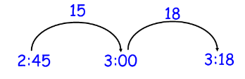  •Partitioning: bridging through 60 to calculate a time interval – What was the time 33 minutes after 2.45pm?  Using known facts and place value to find related facts. | Missing number/digit problems:  Mental methods should continue to develop, supported by a range of models and images, including the number line. The bar model should continue to be used to help with problem solving.  Written methods (progressing to 4-digits)  Expanded column addition modelled with place value counters, progressing to calculations with 4-digit numbers.  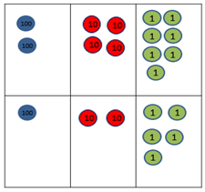  Compact written method  Extend to numbers with at least four digits.  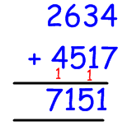  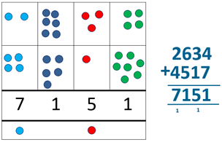  Children should be able to make the choice of reverting to partitioning if experiencing any difficulty.  Add numbers up to two places of decimals (same number of decimals places) and adding several numbers (with different numbers of digits).  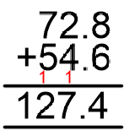

Year 4 - Addition
Key Vocabulary
add, addition, sum, more, plus, increase, sum, total, altogether, double, near double, how many more to make..? how much more? one’s boundary, tens boundary, hundreds boundary, thousands boundary, tenths boundary, hundredths boundary, inverse, how many more/fewer? Equals sign, is the same as.

Key Questions and Generalisations  Investigate when re-ordering works as a strategy for addition. Eg. 120 + 133 = 120 + 130 + 3.  What do you notice?  How do you know?  Links from other curriculum areas  - Estimate and use inverse operations to check answers.  - Solve addition two step problems in context, deciding which operations and methods to use and why.  - Identify, represent and estimate numbers using different representations.  - Recognise the place value of each digit in a four digit number.  - Estimate, compare and calculate different measures, including amounts of money in £ and p (including fractions and decimals) | 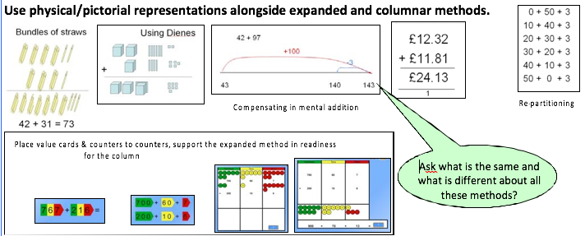  Children’s Representations  Fractions  Addition of fractions with the same denominator to become fluent through a variety of increasingly complex problems beyond one whole.  Counting using simple fractions and decimals, both forwards and backwards.  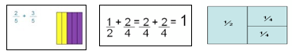 | Mastery  Write down the four relationships you can see in the bar model.  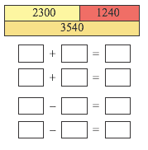  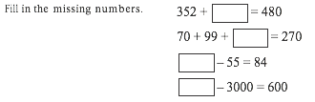  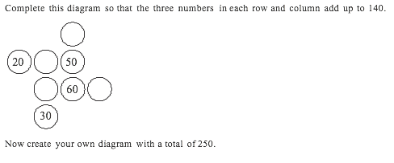  Write three calculations where you would use mental calculation strategies and three where you apply a column method.  Explain the decision you made for each calculation.

Year 5 – Addition
Mental Strategies | Written Method
Children should continue to count regularly, on and back.  The number line should continue to be used as an important image to support thinking, and the use of informal jottings should be encouraged where appropriate.  Children should continue to partition numbers in different ways.  They should be encouraged to choose from a range of strategies:  - Counting forwards and backwards in tenths and hundredths: 1.7 + 0.55  - Reordering: 4.7 + 5.6 – 0.7= 4.7 – 0.7 + 5.6 = 4 + 5.6  - Partitioning: counting on or back 540 + 280= 540 + 200 + 80  - Partitioning: bridging through multiples of 10:  - Partitioning: compensating: 5.7 + 3.9 = 5.7 + 4.0 – 0.1  - Partitioning: using ‘near’ double: 2.5 + 2.6 is double 2.5 and add 0.1 or double 2.6 and subtract 0.1  - Partitioning: bridging through 60 to calculate a time interval: It is 11.45. How many hours and minutes is it to 15.20?  - Using known facts and place value to find related facts.  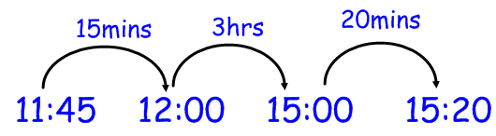  Children should continue to count regularly, on and back, now including steps of powers of 10.  Key Vocabulary  Use vocabulary from previous years; inverse & decimal places, decimal point, tenths, hundredths, thousandths, digits, integers. | Missing number/digit problems:  Mental methods should continue to develop, supported by a range of models and images, including the number line. The bar model should continue to be used to help with problem solving. Children should practise with increasingly large numbers to aid fluency  e.g. 12462 + 2300 = 14762  Focus on what they notice about the digits changing as they add different numbers.  Written methods (progressing to more than 4-digits)  As year 4, progressing when understanding of the expanded method is secure, children will move on to the formal columnar method for whole numbers and decimal numbers as an efficient written algorithm.  Place value counters can be used alongside the columnar method to develop understanding of addition with decimal numbers.  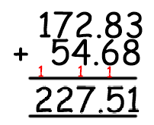  The decimal point should be aligned in the same way as the other place value columns, and must be in the same column in the answer. Pupils should be able to add more than two values, carefully aligning place value columns.  T U . th hth  1 9 . 0 1  3 . 6 5  0 . 7 0  Say “6 tenths add 7 tenths” to reinforce place value.
  Empty decimal places can be
  filled with zero to show the
  place value in each column.

Year 5 – Addition  Key Questions and Generalisations  Sometimes, always or never true? The difference between a 2 digit number (or greater) and its reverse will be a multiple of 9. For example the difference between 23 and 32 is 9.  What do you notice about the differences between consecutive square numbers?  How can the numbers be increased or decreased without the answer changing, what can you generalise? 23+46=24+45  What do you notice?  What’s the same? What’s different?  Can you convince me?  How do you know?  Links from other curriculum areas  Solve problems involving up to three decimal numbers.  Solve addition and subtraction multi step problems in context, deciding which operations and methods to use and why  Use all four operations to solve problems involving measure [e.g. length, mass, volume, money] using  decimal notation,  Calculate the perimeter of composite rectilinear shapes in centimetres and metres  Use angle sum facts and other properties to make deductions about missing angles  Solve comparison, sum and difference problems using information presented in a line graph | Fractions  Add fractions with the same denominator and denominators that are multiples of the same number (to become fluent through a variety of increasingly complex problems and add fractions that exceed 1 as a mixed number)  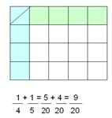  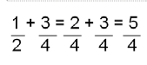  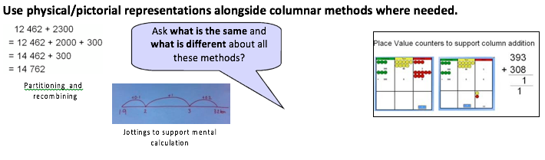  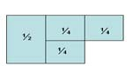  Children’s Representation | Mastery  Set out and solve these calculations using a column method.  3254 + ? = 7999  2431 = ? – 3456  6373 – ? = 3581  6719 = ? – 4562  The table shows the cost of train tickets from different cities.  What is the total cost for a return journey to York for one adult and two children? How much more does it cost for two adults to make a single journey to Hull than  to Leeds?  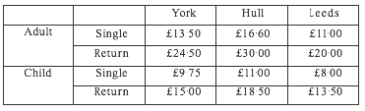  Sam and Tom have £67·80 between them.  If Sam has £6·20 more than Tom, how much does Tom have?  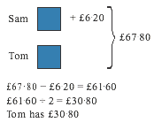
Year 6 – Addition
Mental Strategies | Written Method
Consolidate previous years.  Perform mental calculations, including with mixed operations and large numbers, using and practising a range of mental strategies.  Children should experiment with order of operations, investigating the effect of positioning the brackets in different places, e.g. 20 – 5 x 3 = 5; (20 – 5) x 3 = 45 | Missing number/digit problems:  Mental methods should continue to develop, supported by a range of models and images, including the number line. The bar model should continue to be used to help with problem solving.  Written methods  As year 5, progressing to larger numbers, aiming for both conceptual understanding and procedural fluency with columnar method to be secured.  Continue calculating with decimals, including those with different numbers of decimal places  Problem Solving  Teachers should ensure that pupils have the opportunity to apply their knowledge in a variety of contexts and problems (exploring cross curricular links) to deepen their understanding  Adding several numbers with different numbers of decimal places (including money and measures): Tenths, hundredths and thousandths should be correctly aligned, with the decimal point lined up vertically including in the answer row. Zeros could be added into any empty decimal places, to show there is no value to add.  1 9 . 0 1 2  3 . 6 2 0 Empty decimal places can be filled with a  0 . 7 0 0 zero as a place value holder  To ensure an increased complexity pupils will need to add a several numbers and with more than four digits
Children’s Representations
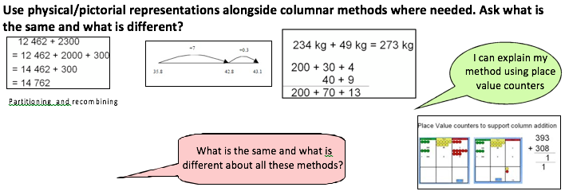

Year 6 – Addition
Key Vocabulary
See previous years.
Key Questions and Generalisations  Order of operations: brackets first, then multiplication and division (left to right) before addition and subtraction (left to right). Children could learn an acrostic such as BODMAS, or could be encouraged to design their own ways of remembering.  Sometimes, always or never true? Subtracting numbers makes them smaller. (Think about negative numbers.)  What do you notice?  What’s the same? What’s different?  Can you convince me?  How do you know?  Links from other curriculum areas  - Use their knowledge of the order of operations to carry out calculations involving the four operations (BODMAS)  - Solve problems involving all four operations  - Algebra: use symbols and letters to represent variable and unknowns e.g. a + b = c  - What do we notice about these numbers? What if c was 5?  - Solve problems involving the calculation and conversions of units of measure, using decimal  notation of up to three decimal places where appropriate  - Using the number line, pupils use, add and subtract positive and negative integers for measures  such as temperature  - Calculate and interpret the mean as an average  - Interpret and construct pie charts and line graphs and use these to solve problems  - Find missing angles, and express geometry relationships algebraically (e.g. d=2r) | Fractions  Add fractions with different denominators and mixed numbers, using the concept of equivalent fractions.  Start with fractions where the denominator of one fraction is a multiple of the other (e.g. ½ + 1/8 = 5/8) and progress to varied and increasingly complex problems.  Practice calculations with simple fractions and decimal equivalents to aid fluency. 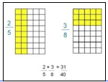 | Mastery  Calculate 36·2 + 19·8  - with a formal written column method  - with a mental method, explaining your reasoning.  Write different number sentences using the digits 2, 3, 5 and 8 before the equals sign, using:  - one operation  - two operations but no brackets  - two operations and brackets  Can you write a number sentence using the digits 2, 3, 5 and 8 before the equals sign, which has the same answer as another number sentence using the digits 2,  3, 5 and 8 but which is a different sentence?  Jasmine and Kamal have been asked to work out 5748 + 893 and 5748 – 893.  Jasmine says, ‘893 is 7 less than 900, and 900 is 100 less than 1000, so I can work out the addition by adding on 1000 and then taking away 100 and then taking away 7.’  What answer does Jasmine get, and is she correct? Explain why.
Year 1 - Subtraction
Mental Strategies | Written Method
Subtract one digit and two digit numbers to 20, including zero.  Read, write and interpret mathematical statements using symbols (+, -, =) signs.  Represent and use number bonds and related addition facts within 20  Solve one step problems using concrete objects and pictorial representations, and missing number problems such as 7 = ? - 9  Memorise and reason with number bonds  Add using objects, Numicon, cubes etc and number lines and tracks  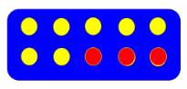  Check with everyday objects  Ensure pre calculation steps are understood, including:  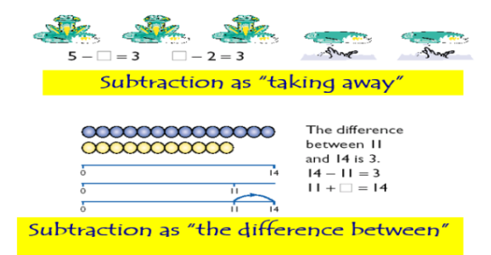  Counting objects, Conservation of number.  Use of 100 square for counting and subtraction | 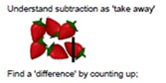  Subtract one digit and two digit numbers to 20, including zero. 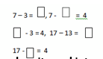  Read, write and interpret mathematical statements involving addition (+), subtraction (–) and equals (=) signs.  Represent and use number bonds and related subtraction facts within 20.  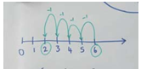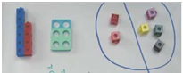  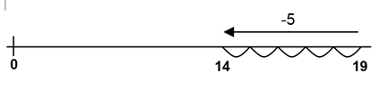  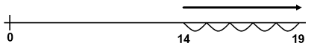  Is it the same answer? Which way is easiest?  Understand subtraction as finding the difference:  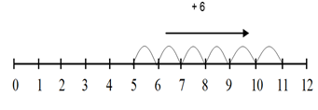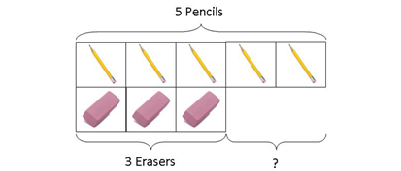
Children’s Representations
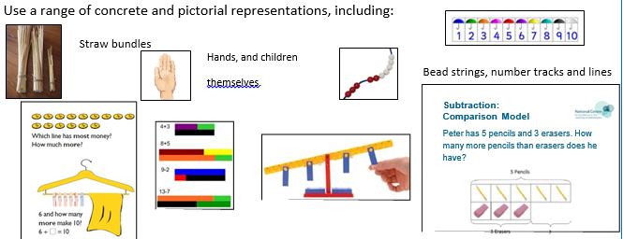
Year 1 - Subtraction
Key Vocabulary
Subtraction, subtract, take away, distance between, difference between, more than, minus, less than, equals = same as, most, least, pattern, odd, even, digit,
Key Questions and Generalisations  - True or false? Subtraction makes numbers smaller  - When introduced to the equals sign, children should see it as signifying equality. They should become used to seeing it in different positions.  Children could see the image below and consider, “What can you see here?” e.g.  3 yellow, 1 red, 1 blue. 3 + 1 + 1 = 5  2 circles, 2 triangles, 1 square. 2 + 2 + 1 = 5  I see 2 shapes with curved lines and 3 with straight lines. 5 = 2 + 3  5 = 3 + 1 + 1 = 2 + 2 + 1 = 2 + 3  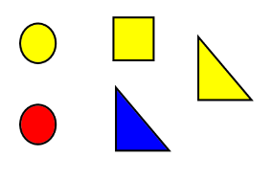  How many more to make…? How many more is… than…? How much more is…? How many are left/left over? How many have gone? One less, two less, ten less… How many fewer is… than…? How much less is…?  What can you see here?  Is this true or false? | Mastery  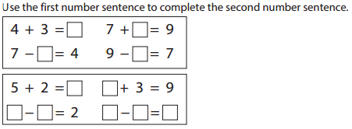  Mastery with greater depth  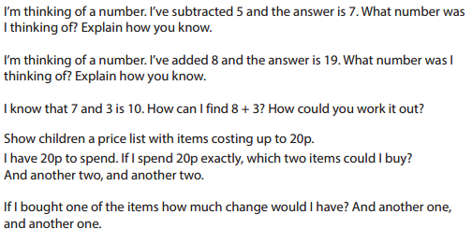
Year 2 - Subtraction
Mental Strategies | Written Method
Add and subtract numbers using concrete objects, pictorial representations, and mentally, including:  - a two digit number and ones  - a two digit number and tens  - 2 two digit numbers  - adding 3 one digit numbers  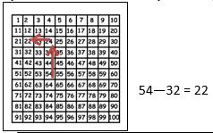 | 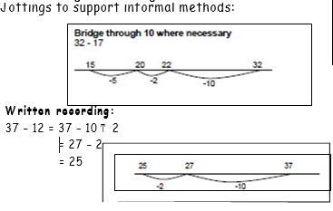  -  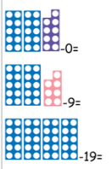  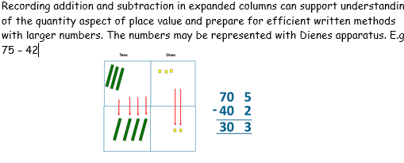  Numicon is used to model subtraction.
Children’s Representations
Informal methods to support written subtraction calculations
Practical partitioning of a 2 digit number
In year 1 leads to:
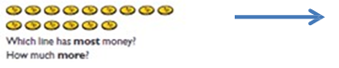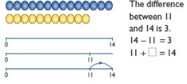
Bundles of straws or Dienes to represent and partition 2 digit numbers.
Subtract (without decomposition) using partitioning and equipment, e.g.



To calculate 35-22, remove 22

Then record: 35-22=13.
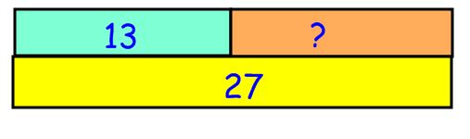

Year 2 - Subtraction
Key Vocabulary
Subtraction, subtract, take away, difference, difference between, minus, tens, ones, partition, near multiple of 10, tens boundary, less than, one less, two less… ten less… one hundred less, more, one more, two more... ten more... one hundred more
Key Questions and Generalisations  - Noticing what happens when you count in tens (the digits in the ones column stay the same)  - Investigate subtraction using odd and even numbers. Odd – odd = even; odd – even = odd; etc  - show that addition of two numbers can be done in any order (commutative) but subtraction of one number from another cannot  - Recognise and use the inverse relationship between addition and subtraction and use this to check calculations and missing number problems. This understanding could be supported by images such as this.  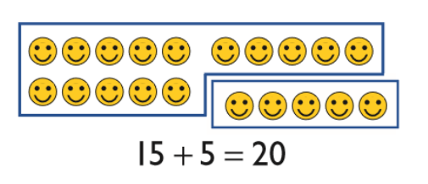  How many more to make…? How many more is… than…? How much more is…? How many are left/left over? How many fewer is… than…? How much less is…?  Is this true or false?  If I know that 7 + 2 = 9, what else do I know? (e.g. 2 + 7 = 9; 9 – 7 = 2; 9 – 2 = 7; 90 – 20 = 70 etc).  What do you notice? What patterns can you see? | Fractions  Pupils should count in fractions up to 10, in halves. | Mastery  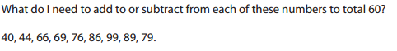  Mastery with Greater Depth  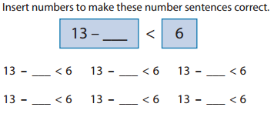

Year 3 - Subtraction
Mental Strategies | Written Method
Add and subtract numbers mentally, including:  Use Place Value Counters PVC at each stage to support conceptual understanding.  - a three digit number and ones  - a three digit number and tens  - a three digit number and hundreds.  Children should continue to count regularly, on and back, now including multiples of 4, 8, 50, and 100, and steps of 1/10.  The number line should continue to be used as an important image to support thinking, and the use of informal jottings should be encouraged.  Children should continue to partition numbers in difference ways.  They should be encouraged to choose the mental strategies which are most efficient for the numbers involved, e.g. counting up (difference, or complementary addition) for 201 – 198; counting back (taking away / partition into tens and ones) for 201 – 12. | 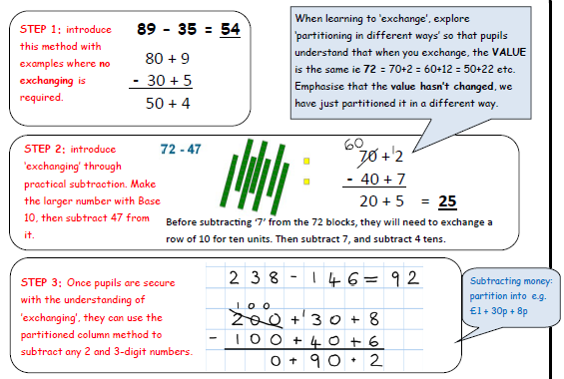  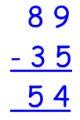  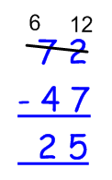  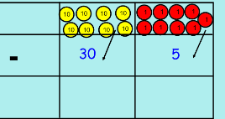  Or PVC  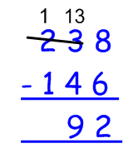  Step 3 – Once pupils are secure with their understanding of ‘exchange’ they can apply it to 3 digit numbers.  Add and subtract numbers with up to three digits, using formal written methods of columnar subtraction with only 1 exchange.  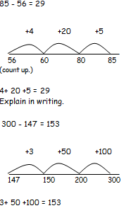  Links to other strands:  - add and subtract lengths (m/cm/mm)  - add and subtract amounts of money to give change using both £ and p in practical contexts  - add and subtract volume/capacity (l/ml) (KPI)  - add and subtract mass (g/kg)  - compare durations of events (e.g. calculate the time taken by a particular event or task)
Children’s Representations
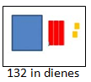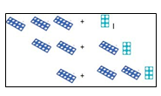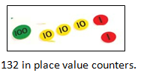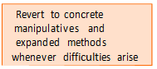

Year 3 - Subtraction
Key Vocabulary
How many? left, gone, take away, leave, less/than difference between, count back, subtract, minus, fewer Hundreds, tens, ones, estimate, partition, recombine, difference, decrease, near multiple of 10 and 100, inverse, rounding, column subtraction, exchange

Key Questions and Generalisations  Noticing what happens to the digits when you count in tens and hundreds.  Odd – odd = even etc (see Year 2)  Inverses and related facts – develop fluency in finding related addition and subtraction facts.  Develop the knowledge that the inverse relationship can be used as a checking method.  What do you notice? What patterns can you see?  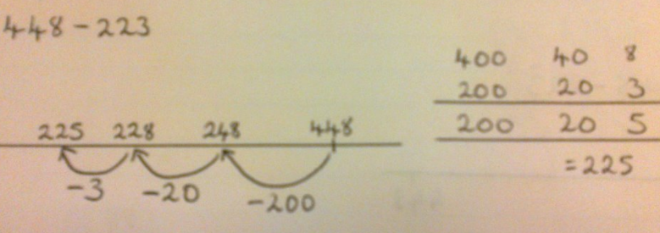  When comparing two methods alongside each other: What’s the same? What’s different? Look at this number in the formal method; can you see where it is in the expanded method / on the number line | Fractions  - count up and down in tenths from any given number, including mixed numbers.  - subtract fractions with the same denominator within one whole. | Mastery  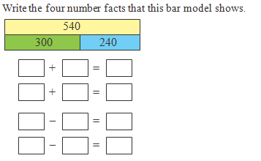  Flo and Jim are answering a problem:  Danny has read 62 pages of the class book, Jack has read 43. How many more pages has Danny read than Jack?  Flo does the calculation 62 + 43. Jim does the calculation 62–43. Who is correct?  Explain how you know.  Pupils might demonstrate using a bar model to explain their reasoning.
Year 4 - Subtraction
Mental Strategies | Written Method
Children should continue to count regularly, on and back, now including multiples of 6, 7, 9, 25 and 1000, and steps of 1/100.  The number line should continue to be used as an important image to support thinking, and the use of informal jottings should be encouraged where appropriate.  Children should continue to estimate answers and partition numbers in different ways.  They should be encouraged to choose from a range of strategies:  - Counting forwards and backwards: 124 – 47, count back 40 from 124, then 4 to 80, then 3 to 77  - Partitioning: counting on or back: 5.6 - 3.5 = 5.6 - 3 + 0.5 = 2.1  - Partitioning: bridging through multiples of 10: 6070 – 4987, 4987 + 13 + 1000 + 70  - Partitioning: compensating 138 – 69 = 138 - 70 + 1  - Partitioning: bridging through 60 to calculate a time interval – What was the time 33 minutes before 2.15pm?  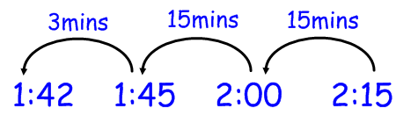  - Using known facts and place value to find related facts. | - Subtract numbers with up to 4 digits using the formal written methods of columnar subtraction where appropriate  - Use inverse operations to check answers to calculations.  - Solve addition and subtraction problems in contexts, deciding which operations (+ or -) and methods (Singapore bar, number line, columnar subtraction) Remember to use place value counters to support understanding further.  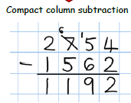  Links to other strands:  - Identify, represent and estimate numbers using different representations. (Place value)  - Recognise the place value of each digit in a four digit number.  - Solve addition and subtraction two  - Estimate, compare and calculate different measures, including money in pounds and pence.
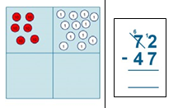
Children’s Representations 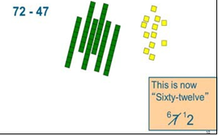

Year 4 - Subtraction
Key Vocabulary
Minus, take away, subtract, equal to, how many more to make..? how much more? inverse, how many more/fewer? is the same as, exchange, decrease, fewer than, less than, difference between, most, least, bridge, partition.
Key Questions and Generalisations  Investigate when re-ordering works as a strategy for subtraction. Eg. 20 – 3 – 10 = 20 – 10 – 3, but 3 – 20 – 10 would give a different answer.  What do you notice?  What’s the same? What’s different?  Can you convince me?  How do you know? | Fractions  - count up and down in hundredths from any given number, including mixed numbers  - subtract fractions with the same denominator  - solve simple measure and money problems involving fractions and decimals to two decimal places | Mastery  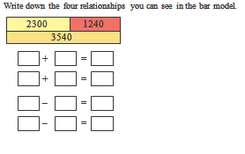  Mastery with Greater Depth  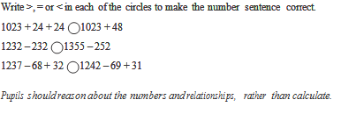

Year 5 - Subtraction
Mental Strategies | Written Method
Consolidate and decide upon appropriate mental strategies: find differences by counting up, partitioning, applying known facts, bridging through 10 and multiples of 10, subtracting 9,11 etc by compensating, counting on to, or back from the largest number.  Subtracting numbers mentally with increasingly large numbers. Eg. 12,462 – 2300 = 10,162  Use rounding and inverse operation to check calculations  Adding and subtracting decimals, including a mix of whole numbers and decimals, decimals with different numbers of decimal places and complements of 1. E.g. 1-0.17=0.83  Adding and subtracting tenths, and one-digit whole numbers and tenths  Use appropriate mental strategies to solve problems involving time, money and measure. | Subtract whole numbers with more than 4 digits, including using formal written methods (columnar subtraction).  Practise adding and subtracting decimals.  Use subtraction to solve problems involving time, money and measure using decimal notation (up to 3d.p.)
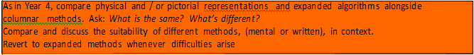
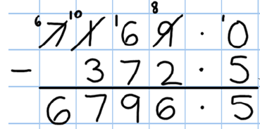
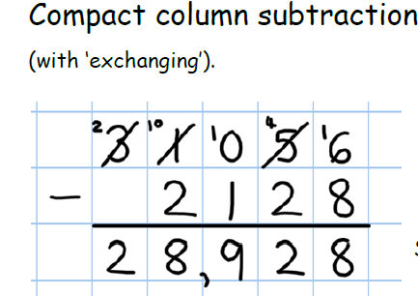
Children’s Representations
Year 5 - Subtraction
Key Vocabulary
How many? left, gone, take away, leave, less/than difference between, count back, subtract, minus, fewer, exchange, decrease, tenths boundary

Key Questions and Generalisations  When considering relationships between physical, pictorial and written calculations:  What is the same?  What is different?  Compare and discuss the suitability of different methods, (mental or written), in context – which is the most efficient method? | Fractions  Subtract fractions with the same denominator and denominators that are multiples of the same number. (Include fractions exceeding 1 as a mixed number.)  Solve problems involving number up to three decimal places.  Mentally add and subtract tenths, one-digit whole numbers and tenths. | Mastery  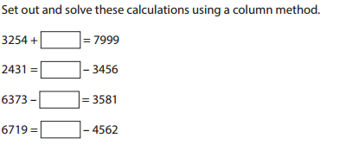  Mastery with Greater Depth  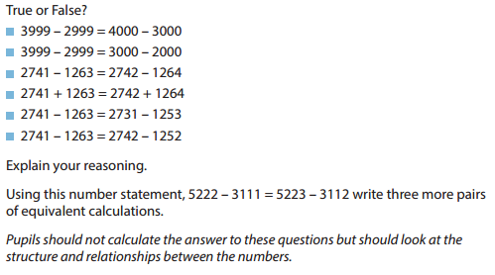

Year 6 - Subtraction
Mental Strategies | Written Method
Perform mental calculations, including with mixed operations and large numbers.  Use estimation and inverse operation to check answers to calculations and determine, in the context of a problem, an appropriate degree of accuracy.  Use inverse knowledge to solve calculations.  Undertake mental calculations with increasingly large numbers and more complex calculations.  Use appropriate mental strategies to solve problems involving time, money and measure of up to three decimal places where appropriate.  Example Questions  What is 2 minus 0.005?  What is the difference between 5.7 and 8.304?  12 980 + _______ = 13125  23,111 – 47 =  149 + 137 + ______ = 650  What is the difference between 10:23 and 11:35? | Add and subtract whole numbers with more than 4 digits, including using formal written methods (columnar addition and subtraction).  Solve problems involving the calculation and conversions of units of measure, time and money using decimal notation of up to three decimal places where appropriate.  Children’s Representations  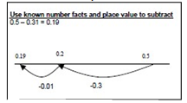  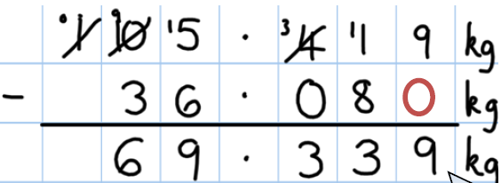  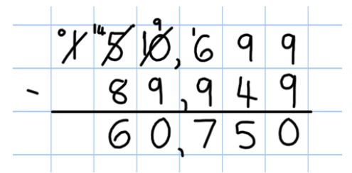  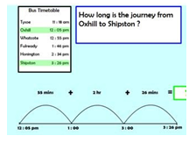

Year 6 - Subtraction
Key Vocabulary
How many? left, gone, take away, leave, less/than difference between, count back, subtract, minus, fewer, exchange

Key Questions and Generalisations  What is the same?  What’s different?  How can we use our existing knowledge to help us solve the problem?  Compare and discuss the suitability of different methods, (mental or written), in context – which is the most efficient method?  Which method would you choose for this calculation and why? | Fractions  Add and subtract fractions with different denominators and mixed numbers.  They practise calculations with simple fractions and decimal fraction equivalents to aid fluency. | Mastery  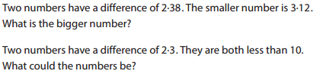  Mastery with Greater Depth  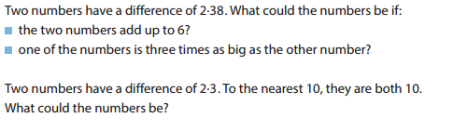

Year 1 - Multiplication
Mental Strategies | Written Methods
Children should; count, read and write numbers to 100 in numerals; count in multiples of twos, fives and tens; double numbers to 10; halve even numbers up to 20; begin to see the patterns of counting in 2s, 5s, 10s and develop the language of multiplication.  Counting in 2s; animal legs, shoes, socks… Counting in 5s; fingers, toes, gloves…  Develop the vocabulary by encouraging children to explain what they are doing. | Children do not need to record number sentences using the symbols. This may be modelled to them along with pictures, arrays, number lines and props such as Numicon.  Signs and symbols  2 x 2= = 2 x 2  2 x = 4 4 = x 2  NB Teacher to model jottings.  Children will be introduced to arrays to model ‘groups of’.  Number lines ( number lines)  2 x 2  ___________________  0 2 4  Pictures/marks  There are 2 sweets in a bag. How many sweets in 5 bags?  O O  o  O O  o  O O  o  O O  o  O O  o
Children’s Representations
Explaining methods and reasoning orally.

How many wheels do we need to make 3 lego cars?
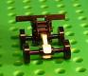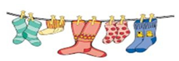

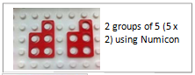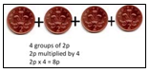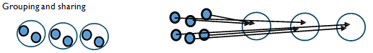Also experience ‘lots of’ on bead strings.

Year 1 - Multiplication
Key Vocabulary
lots of, groups of ,double, steps of, jumps of, doubling, columns, rows, ones, repeated addition
times, longer, bigger, higher etc
Key Questions and Generalisations  Understand 6 counters can be arranged as 3+3 or 2+2+2  Understand that when counting in twos, the numbers are always even.  Why is an even number an even number?  (use numicon to show this)  What do you notice?  What’s the same? What’s different?  Can you convince me?  How do you know?  Count up and down in 2s, 5s, 10s with number lines, props and songs.  What comes next?  What is the sequence?  Could this number be next?  Why / why not?  Solve one step problems involving multiplication and division, by calculating the answer using concrete. | Fractions  Start using vocabulary related to fractions e.g. half, quarter, whole. Relate fractions to sharing out and measures.  Respond to fractions in real life contexts, for example;  Half fill this jug.  Is this pot/ cylinder/ container / jug less/ more than / about half filled?  Shade ½ of this rectangle, circle…  Fold this picture in half.  Cut half way along the line.  Can you split these sweets into two equal groups? You now have half each.  Look at the clock, the big hand is half way around the clock, it is at 6 and the little hand is half way between the 2 and 3 so the time is half past 3. | Mastery  Count in multiples of twos, fives and tens from different multiples to develop recognition of patterns in the number system. Discuss and solve problems with manipulatives and props. Work with arrays to develop understanding.  Mastery Examples:  Ask pupils to use concrete objects to answer questions such as:  What is double 4? What is half of 6?  Show pupils pictures or groups of objects like the examples below. Ask questions such as ‘How many biscuits are there altogether?’  ‘How many cherries are there altogether?’  Observe how pupils count the objects. Do they count in twos, fives etc. or do they count in ones?  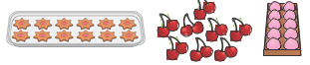  Mastery with Greater Depth Examples:  If I start on 0 and count on in fives will I say the number 55? If I start on 4 and count on in twos will I say the number 17? If I start at 10 and count on in tens will I say 100?  How do you know?
Year 2 - Multiplication
Mental Strategies | Written Method
Doubling and halving  Applying the knowledge of doubles and halves to known facts. Double numbers to 10 for rapid recall. Use this knowledge to double larger numbers.  e.g. 8 x 4 is double 4 x 4  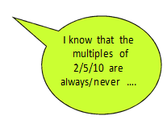  Rapid recall of multiplication facts.  2 times table  5 times table  10 times table  Connect the 5 and 10 times tables and relate multiplying by 10 to place value.  Recognise odd and even numbers and relate this to the 2x table.  Show that multiplication of two numbers can be done in any order (commutativity). Knowing that 3 X 5 = 5 X 3.  The use of arrays will support this understanding.  Use a variety of language to describe multiplication and division of 2/ 5/10 | Calculate mathematical statements for multiplication and division within the multiplication tables and write them using the multiplication (x), division (÷) and equals (=) signs.  6 x 2 = = 2 x 6  6 x = 12 12 = x 6  x 2 = 12 12 = 2 x  x = 12 12 = x  Extend to 4 x5 = 10 x  Other jottings may include arrays, pictures or repeated addition with a number line or signs.  O O  O O  O O  O O  Array  O O O O  O O O O  2 x 4  Or 4 x 2  Repeated addition  2 x 4 = 2 + 2 + 2 + 2  Number lines  Using the idea of multiplication as repeated addition.  ___________________________  0 3 6 9 12 15 18 3 x 6  Towards written methods  Use jottings to develop an understanding of doubling two digit numbers.    16  10 6  x2 x2  20 12 So 20+ 12 = 20+10+2
Children’s Representations
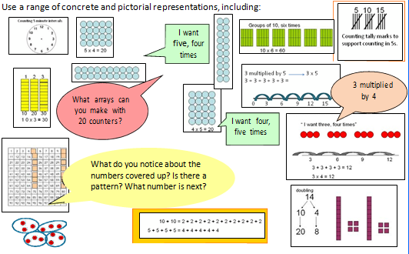
Year 2 - Multiplication
Key Vocabulary
lots of, groups of ,double, steps of, jumps of, doubling, multiples, times, multiply, multiplied by, repeated addition, array, row, column, twice, inverse operation, divide
Key Questions and Generalisations  Commutative law shown on array (video)  Links to Teachers TV from NCTEM Website – use counters and flip the array around.  Repeated addition can be shown mentally on a number line.  How many lots of…?  Can you work out … with an array or number line?  Explore the inverse relationship between multiplication and division. Use an array to explore how numbers can be organised into groups.  What do you notice?  What is the same? What is different?  Can you convince me?  How do you know?  Pupils may be able to carry out certain procedures and answer questions like the ones outlined, but the teacher will need to check that pupils really understand the idea by asking questions such as ‘Why?’, ‘What happens if …?’, and checking that pupils can use the procedures or skills to solve a variety of problems. | Fractions  I have half, I have 10, how many were there? | Mastery  Children should be able to commit multiplication facts to memory and understand the concept. They should demonstrate this when solving problems. Pupils should look for and recognise patterns within tables and connections (e.g. 5x is half of 10x).  Pupils should be able to demonstrate understanding in a range of contexts including;  measurement – counting 5 minute intervals on a clock face and using money to support counting in 2s, 5s, 10s, 20s, 50s and 100s.  Mastery Example:  Sally buys 3 cinema tickets costing £5 each. How much does she spend? Write the multiplication number sentence and calculate the cost.  If Sally paid with a £20 note, how much change would she get?  Mastery with Greater Depth Example:  Together Rosie and Jim have £12. Rosie has twice as much as Jim. How much does Jim have? The bar model can be useful here.  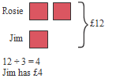

Year 3 - Multiplication
Mental Strategies | Written Method
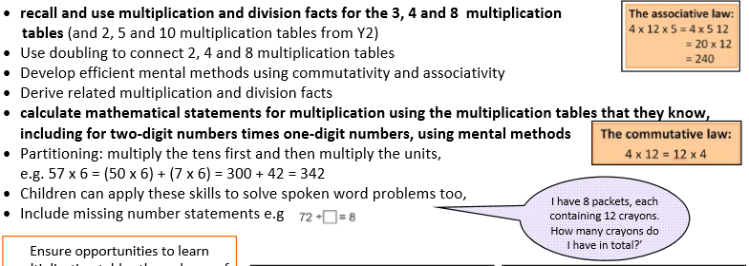 | Written methods (progressing to 2digit x 1digit)  Introduce the grid method with children physically making an array to represent the calculation (e.g. make 8 lots of 23 with 10s and 1s place value counters), then translate this to grid method format.  Developing written methods using understanding of visual images  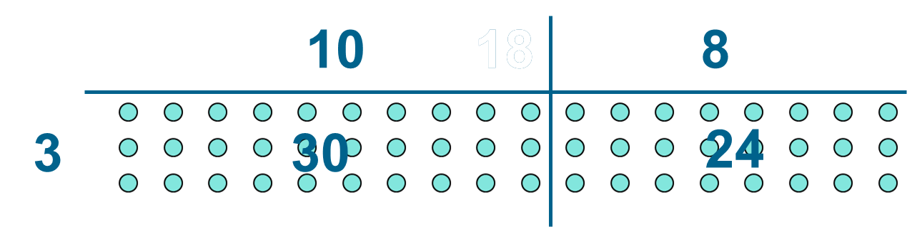  Develop onto the grid method  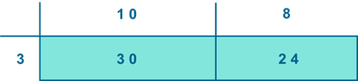  Give children opportunities for children to explore this and deepen understanding using Dienes apparatus and place value counters. Perhaps leading to:  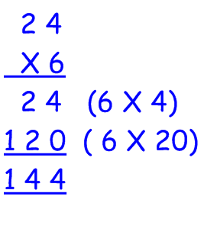
Children’s Representations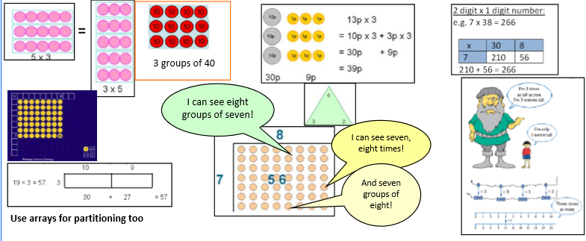
Year 3 - Multiplication
Key Vocabulary
Partition, grid method, inverse, groups of, lots of, times, array, altogether, multiply, count, multiplied by, repeated addition, column, row, commutative, sets of, equal groups, times, times as big as, once, twice, three times, partition, grid method, multiple, product, tens, units, value
Key Questions and Generalisations  Connecting x2, x4 and x8 through multiplication facts  Comparing times tables with the same times tables which is ten times bigger. If 4 x 3 = 12, then we know 4 x 30 = 120. Use place value counters to demonstrate this.  When they know multiplication facts up to x12, do they know what x13 is? (i.e. can they use 4x12 to work out 4x13 and 4x14 and beyond?)  What do you notice?  What’s the same? What’s different?  Can you convince me?  How do you know? | Fractions  recognise, find and write fractions of a discrete set of objects: unit fractions and non-unit fractions with small denominators  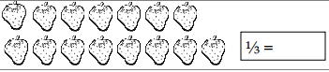  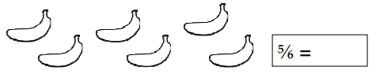  recognise and show, using diagrams, equivalent fractions with small denominators  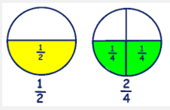 |  | Mastery  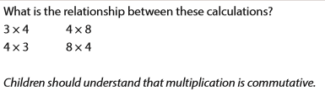  Mastery with depth  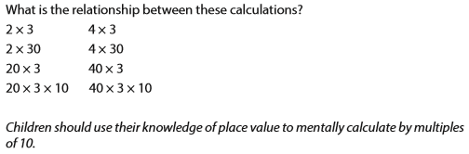
Year 4 - Multiplication  Mental Methods  Children should continue to count regularly, on and back, now including multiples of 6, 7, 9, 25 and 1000, and steps of 1/100.  Become fluent and confident to recall all tables to x 12  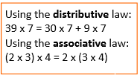  Use the context of a week and a calendar to support the 7 times table (e.g. how many days in 5 weeks?)  Use of finger strategy for 9 times table.  Multiply 3 numbers together  The number line should continue to be used as an important image to support thinking, and the use of informal jottings should be encouraged.  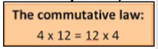  They should be encouraged to choose from a range of strategies:  - Partitioning using x10, x20 etc  - Doubling to solve x2, x4, x8  - Recall of times tables  Use of commutativity of multiplication |  | Written Methods  (progressing to 3digit x 2digit)  Children to embed and deepen their understanding of the grid method to  multiply up 2d x 2d. Ensure this is still linked back to their understanding of arrays and place value counters.  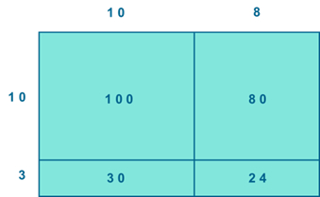  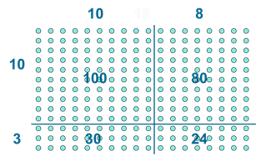  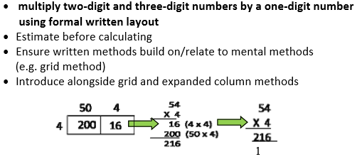  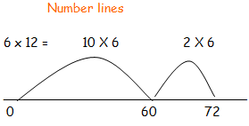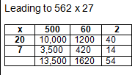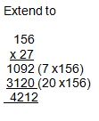
Children’s Representations
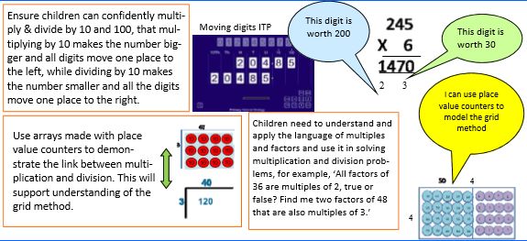

Year 4 - Multiplication
Key Questions and Generalisations  Children given the opportunity to investigate numbers multiplied by 1 and 0.  When they know multiplication facts up to x12, do they know what x13 is? (i.e. can they use 4x12 to work out 4x13 and 4x14 and beyond?)  What do you notice?  What’s the same? What’s different?  Can you convince me?  How do you know? | Fractions  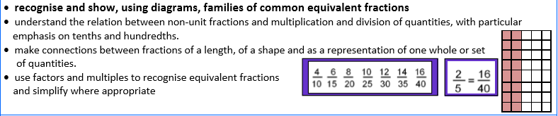  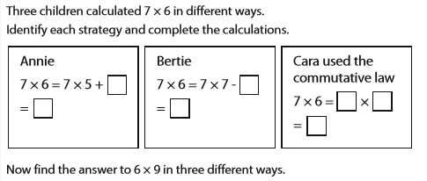  Mastery  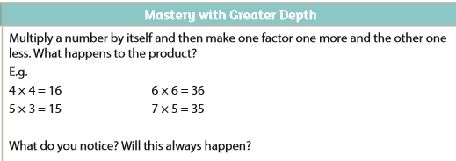

Year 5 - Multiplication
Key Vocabulary
cube numbers, prime numbers, square numbers, common factors, prime number, prime factors, composite numbers groups of, lots of, times, array, altogether, multiply, count, multiplied by, repeated addition, column, row, commutative, sets of, equal groups, times as big as, once, twice, three times, partition, grid method, total, multiple, product, inverse, square, factor, integer, decimal, short/long multiplication
Mental Strategies
Children should continue to count regularly, on and back, now including steps of powers of 10.
Multiply by 10, 100, 1000, including decimals (Moving Digits ITP)
The number line should continue to be used as an important image to support thinking, and the use of informal jottings should be encouraged.
They should be encouraged to choose from a range of strategies to solve problems mentally:
- Partitioning using x10, x20 etc
- Doubling to solve x2, x4, x8
- Recall of times tables
- Use of commutativity of multiplication
If children know the times table facts to 12 x 12. Can they use this to recite other times tables (e.g. the 13 times tables or the 24 times table)
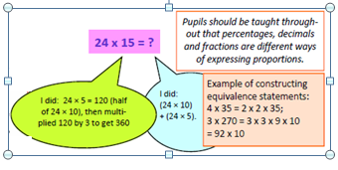

Year 5 - Multiplication
Written Methods
Short multiplication for multiplying by one digit
Pupils could be asked to work out a given calculation using the grid, and then compare it to „your‟ column method. What are the similarities and differences? Unpick the steps and show how it reduces the steps.
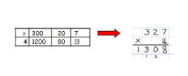

Long multiplication for multiplying by 2 digits
Long multiplication using place value counters
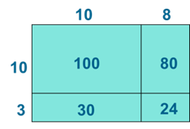
Children to explore how the grid method supports an understanding of long multiplication (for 2digit x 2digit)
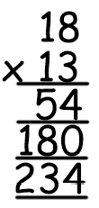

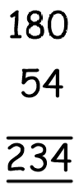
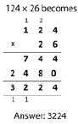
Multiply numbers up to 4 digits by a one or two digit number using a formal written method including long multiplication.
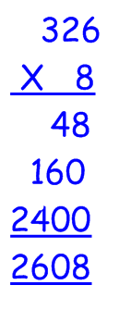
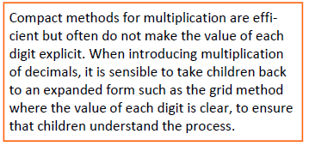
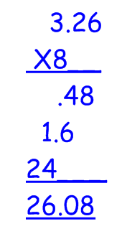

Year 5 – Multiplication
Key Questions and Generalisations  Relating arrays to an understanding of square numbers and making cubes to show cube numbers.  Understanding that the use of scaling by multiples of 10 can be used to convert between units of measure (e.g. metres to kilometres means to times by 1000)  What do you notice?  What’s the same? What’s different?  Can you convince me?  How do you know?  How do you know this is a prime number? | Fractions  - Multiply proper fractions by mixed numbers and whole numbers supported my materials and diagrams  - Identify, name and write equivalent fractions of a given fraction, represented visually, including tenths and hundredths.  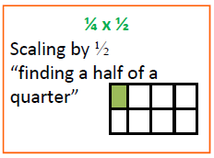  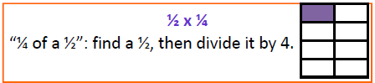  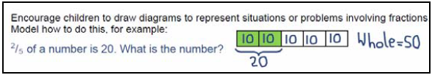 | Mastery:  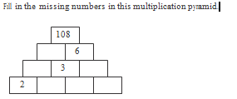  Mastery with depth:  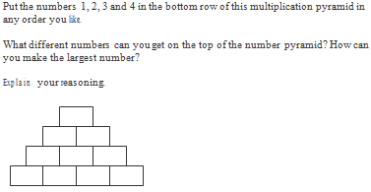

Year 6 - Multiplication
Mental Strategies | Written Methods
Perform mental calculations, including with mixed operations and large numbers (increasingly large numbers & more complex calculations).  Use all the multiplication tables to calculate mathematical statements in order to maintain fluency.  Use estimation to check answers to calculation & determine, in the context of a problem, an appropriate degree of accuracy.  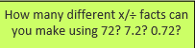  Identify the value of each digit in numbers given to 3 decimal places and multiply and divide number 10, 100, 1000 giving answers to 3 decimal places.  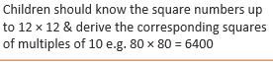    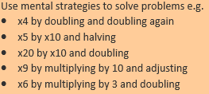 | 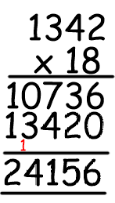  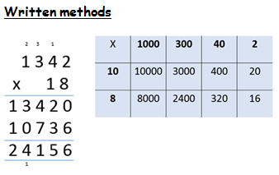  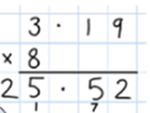  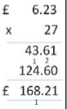  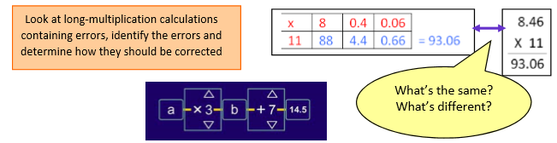  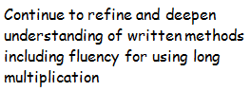  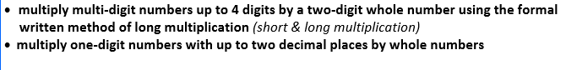  Remind children that the single digit should be in the units column
Children’s Representations 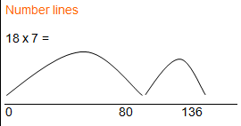

Links to other curriculum areas Identify multiples & factors, including all factor pairs of a number,& common factors of two numbers. Know and use the vocabulary of prime numbers, prime factors and composite (non prime) numbers. Solve problems involving multiplication and division including their knowledge of factors and multiples, squares and cubes, including understanding the meaning of the equal sign. Solve problems involving multiplication and division, including scaling by simple fractions and problems involving simple rates. Use all four operations to solve problems involving measures and decimal notation, including scaling. Convert between different units of metric measure: problems including money. Ratio.

xidentifycommonfactors,commonmultiplesandprimenumbers x usetheirknowledgeoftheorderofoperationstocarryoutcalculationsinvolvingthefouroperations x solveproblemsinvolvingaddition,subtraction,multiplicationanddivision x exploretheorderofoperationsusingbrackets;forexample,2+1x3=5and(2+1)x3=9. x Fractions,decimalsandpercentagesincludingequivalencesindifferentcontexts. x solveproblemsinvolvingtherelativesizesoftwoquantitieswheremissingvaluescanbefoundbyusinginteger multiplicationanddivisionfacts x solveproblemsinvolvingthecalculationofpercentages[forexample,ofmeasures,andsuchas15%of360]andthe useofpercentagesforcomparison x solveproblemsinvolvingsimilarshapeswherethescalefactorisknownorcanbefound x solveproblemsinvolvingunequalsharingandgroupingusingknowledgeoffractionsandmultiples. xAlgebraincludingformulae,linearnumbersequences,combinationsofvariables xMeasurementincludingsolvingproblemswithconversionofunits,decimalnotation,area&volume xStatisticsincludingpiecharts,linechartsandcalculatingthemean
Key Vocabulary
common factor groups of, lots of, double, jumps of doubling, groups of times, array, altogether, multiply, count, multiplied by, repeated addition, array, column, row, commutative, sets of, equal groups, times as big as, once, twice, three times, partition, grid method, total, multiple, product, inverse, square, factor, integer, decimal, short / long multiplication, tenths, hundredths, decimal, quotient
Key Questions and Generalisations  Learn about order of operations BODMAS brackets first, division, multiplication, addition, subtraction  Need to investigate the commutative nature of multiplication  Show how the arrays match the long multiplication steps  Look at different methods using the Nrich investigation Method in Multiplying Madness | 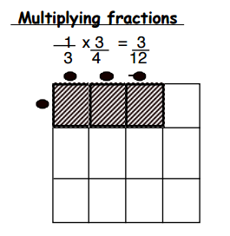  Fractions  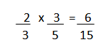  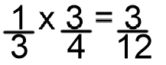 | Mastery  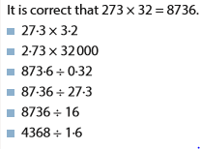  Use this fact to work out.  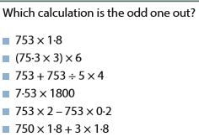  Show your reasoning  Mastery with depth
Year 1 - Division
Mental Strategies | Written Method
Solve one step problems involving multiplication and division, by calculating the answer by using concrete objects, pictorial representations and arrays with the support of the teacher.  Children should experience regular counting on and back from different numbers in 1s and in multiples of 2, 5 and 10.  They should begin to recognise the number of groups counted to support understanding of relationship between multiplication and division.  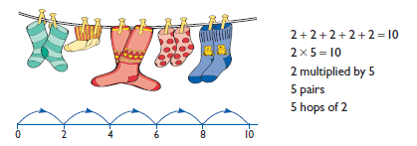  Children should begin to understand division as both sharing and grouping. Sharing, 6 sweets are shared between 2 people. How many do they have each?  Grouping- How many 2’s are in 6?  They should use objects to group and share amounts to develop understanding of division in a practical sense. E.g. using Numicon to find out how many 5’s are in 30? How many pairs of gloves if you have 12 gloves?  Children should begin to explore finding simple fractions of objects, numbers and quantities. E.g.16 children went to the park at the weekend. Half that number went swimming. How many children went swimming? | Children should be given opportunities to reason about what they notice in number patterns.  Group AND share small quantities- understanding the difference between the two concepts.  Sharing  Develops importance of one-to-one correspondence.  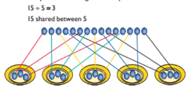  Children should be taught to share using concrete apparatus.  Grouping  Children should apply their counting skills to develop some understanding of grouping.  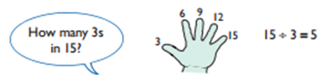  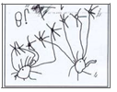  Use of arrays as a pictorial representation for division. 15 ÷ 3 = 5 There are 5 groups of 3.  15 ÷ 5 = 3 There are 3 groups of 5.    Initially children use their own recording moving towards fluent, symbolic notation in year 2.  Mastery  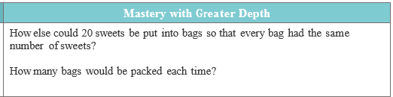  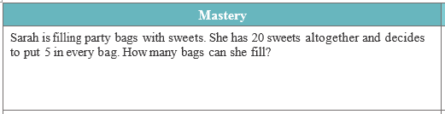
Year 1 - Division
Children’s Representations
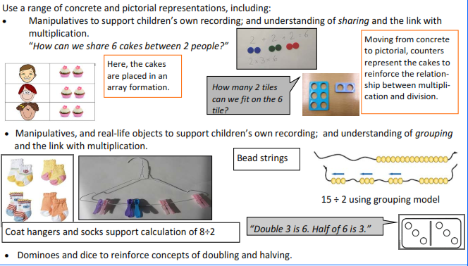

Key Questions and Generalisations  - True or false? Here’s a pile of socks…can I pair them all up?  - What’s the same and what’s different? Look at these 2 piles of socks…can you compare them?  - Grouping and sharing are different types of problems. Some problems need solving by grouping and some by sharing. Encourage children to practically work out which they are doing.  - How many groups of…?  - How many in each group?  - Share… equally into…  - What can you notice? | Fractions  Find half a number of objects through practical sharing.

Year 1 - Division
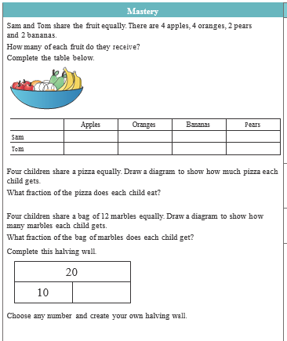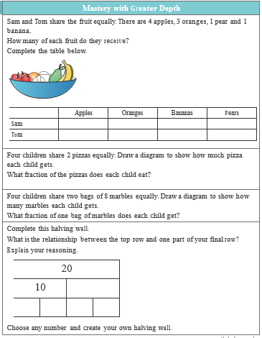
Key Vocabulary
share, share equally, one each, two each…, group, groups of, lots of, array

Year 2 - Division  Mental Strategies  Children should count regularly, on and back, in steps of 2, 3, 5 and 10.  Children who are able to count in twos, threes, fives and tens can use this knowledge to work out other facts such as 2 × 6, 5 × 4, 10 × 9. Show the children how to hold out their fingers and count, touching each finger in turn. So for 2 × 6 (six twos), hold up 6 fingers:    Touching the fingers in turn is a means of keeping track of how far the children have gone in creating a sequence of numbers. The physical action can later be visualised without any actual movement.  This can then be used to support finding out ‘How many 3’s are in 18?’ and children count along fingers in 3’s therefore making link between multiplication and division.  Children should continue to develop understanding of division as sharing and grouping.  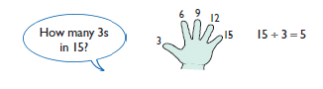  15 pencils shared between 3 pots, how many in each pot?  Children’s Representations  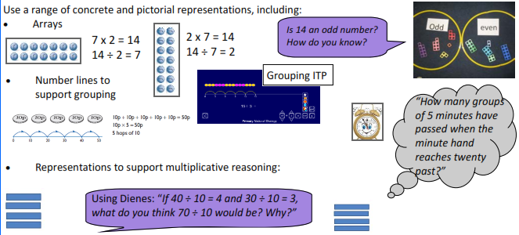  Year 2 - Division  Children’s Representations (cont.)  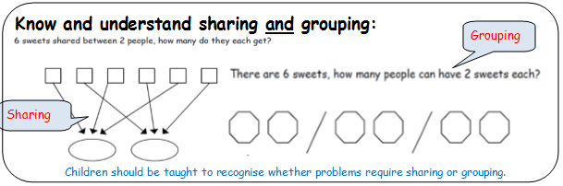 | Written Methods  Pupils decode a problem first, represent it using manipulatives and jottings; and finally record it symbolically.  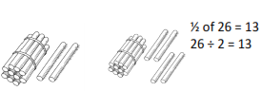  Know and understand sharing and grouping- introducing children to the ÷ sign.  Children should continue to use grouping and sharing for division using practical apparatus, arrays and pictorial representations.  Grouping using a numberline  Group from zero in jumps of the divisor to find our ‘how many groups of 3 are there in 15?’.  15 ÷ 3 = 5  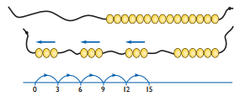  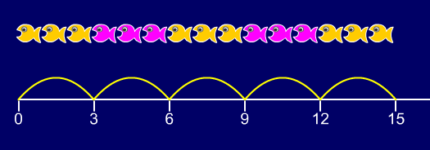  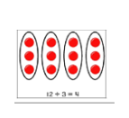  Continue work on arrays. Support children to understand how multiplication and division are inverse. Look at an array – what do you see? What else do you see?  ÷ = signs and missing numbers  6 ÷ 2 = = 6 ÷ 2  6 ÷ = 3 3 = 6 ÷  ÷ 2 = 3 3 = ÷ 2  ÷ ∇ = 3 3 = ÷ ∇  Key Questions and Generalisations  An understanding of the more you share between, the less each person will get (e.g. would you prefer to share these grapes between 2 people or 3 people? Why?)  Secure understanding of grouping means you count the number of groups you have made. Whereas sharing means you count the number of objects in each group.  Some Key Questions  How many 10s can you subtract from 60?  I think of a number and double it. My answer is 8. What was my number?  If 12 x 2 = 24, what is 24 ÷ 2?  Questions in the context of money and measures (e.g. how many 10p coins do I need to have 60p? How many 100ml cups will I need to reach 600ml?)  - True or false? I can only halve even numbers?  - True or false? 4 x 3 = 12 so 3 ÷ 12 = 4  - What’s the same and what’s different?  12 ÷ 3 = 4  12 ÷ 4 = 3
Fractions
Recognise, find, name and write fractions Ы, ¼, ¾, 2/4 of a length, shape, set of objects or quantity.
Write simple fractions for example, ½ of 6 = 3 and recognise the equivalence of ½ and 2/4.

Key Vocabulary
group in pairs, 3s … 10s equal, groups of, divide, ÷, divided by, divided into, share equally, one each, two each…, group, equal groups of, lots of, array, divide, divided by, divided into, division, grouping, number line, left, left over
Mastery
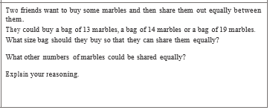
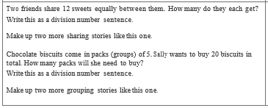

Year 3 - Division
Mental Strategies | Written Method
Children should count regularly, on and back, in steps of 3, 4 and 8. Children are encouraged to use what they know about known times table facts to work out other times tables.  This then helps them to make new connections (e.g. through doubling they make connections between the 2, 4 and 8 times tables).  Children will make use of multiplication and division facts they know to make links with other facts.  3 x 2 = 6, 6 ÷ 3 = 2, 2 = 6 ÷ 3  30 x 2 = 60, 60 ÷ 3 = 20, 2 = 60 ÷ 30  They should be given opportunities to solve grouping and sharing problems practically (including where there is a remainder but the answer needs to given as a whole number)  e.g. Pencils are sold in packs of 10. How many packs will I need to buy for 24 children?  Children should be given the opportunity to further develop understanding of division (sharing) to be used to find a fraction of a quantity or measure.  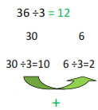  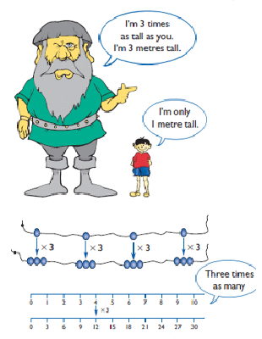 | ÷ = signs and missing numbers  Continue using a range of equations as in year 2 but with appropriate numbers.  Grouping  How many 6’s are in 30?  30 ÷ 6 can be modelled as:  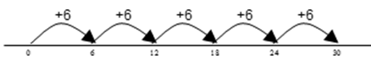  Becoming more efficient using a numberline  Children need to be able to partition the dividend in different ways.  48 ÷ 4 = 12  Sharing – 49 shared between 4. How many left over? Grouping – How many 4s make 49. How many are left over?  +40 + 8    10 groups 2 groups  Remainders  49 ÷ 4 = 12 r1      +40 + 8 + 1  10 groups 2 groups  10x4=40 2x4=8  Place value counters can be used to support children apply their knowledge of grouping. For example: 60 ÷ 10 = How many groups of 10 in 60? 600 ÷ 100 = How many groups of 100 in 600?  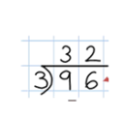  Once children are secure with division as grouping and demonstrate this using number lines, arrays etc., short division for larger 2-digit numbers should be introduced, initially with carefully selected examples requiring no calculating of remainders at all. Start by introducing the layout of short division by comparing it to an array.  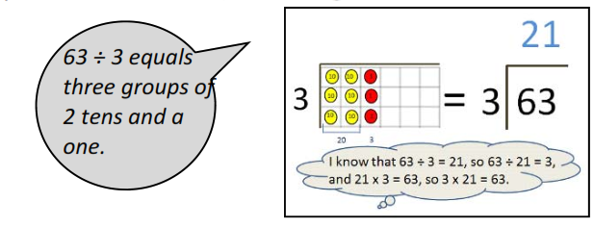
Year 3 - Division
Key Questions and Generalisations  Inverses and related facts – develop fluency in finding related multiplication and division facts.  Develop the knowledge that the inverse relationship can be used as a checking method.  Questions in the context of money and measures that involve remainders (e.g. How many lengths of 10cm can I cut from 81cm of string? You have £54. How many £10 teddies can you buy?)  What is the missing number? 17 = 5 x 3 + __  __ = 2 x 8 + 1  - True or false? There are always 4 different number sentences in a number family?  - What’s the same and what’s different?  32 ÷ 8 =  33 ÷ 8 = | Fractions  Use children’s intuition to support understanding of fractions as an answer to a sharing problem.  3 apples shared between 4 people = $\frac{3}{4}$  Recognise and show, using diagrams, equivalent fractions with small denominators.  Recognise, find and write fractions of a discrete set of objects: unit fractions and non-unit fractions with small denominators.  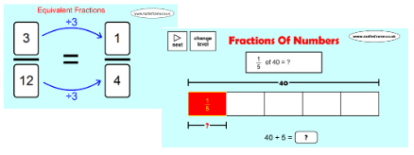 | Mastery  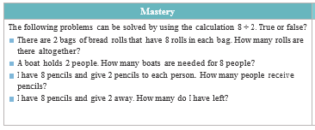  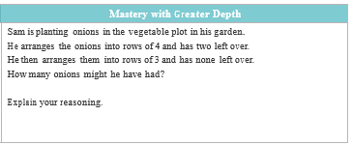
Key Vocabulary
Inverse, share, share equally, one each, two each…, group, equal groups of, lots of, array, divide, divided by, divided into, division, grouping, number line, left, left over, inverse, short division, remainder, multiple

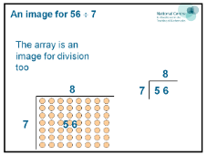
Children’s Representations
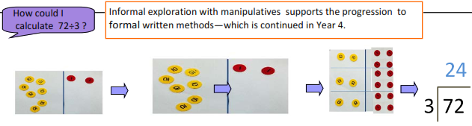

Year 4 - Division
Mental Strategies | Written Methods
Pupils should be taught to:  - recall multiplication and division facts for multiplication tables up to 12 × 12  - use place value, known and derived facts to multiply and divide mentally  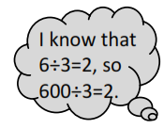  - recognise and use factor pairs and commutativity in mental calculations  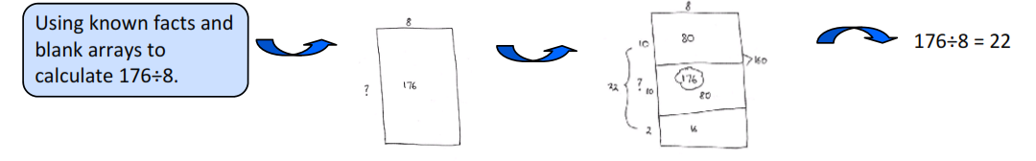  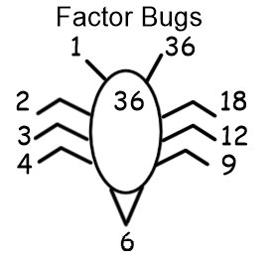 | 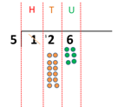  Short division to be modelled for understanding using place value counters as shown below. Calculations with 2 and 3-digit dividends. E.g. fig 1  Use number line division and fact boxes  Particularly in term one.  Pupils move onto dividing numbers with up to 3-digits by a single digit, however problems and calculations provided should not result in a final answer with remainder at this stage.  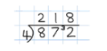  [Type a quote from the document or the summary of an interesting point. You can position the text box anywhere in the document. Use the Text Box Tools tab to change the formatting of the pull quote text box.]  When the answer for the first column is zero (1 ÷ 5, as in example), children could initially write a zero above to acknowledge its place  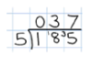
Children’s Representations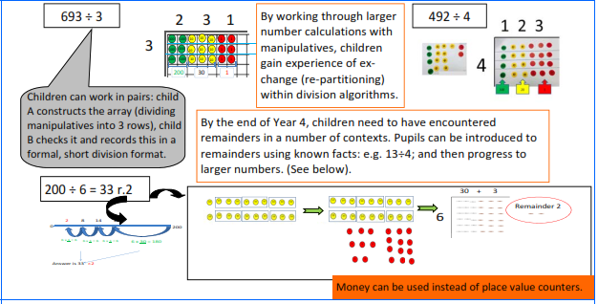 | Fractions and Decimals  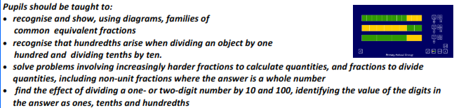

Year 4 - Division
Key Vocabulary
divide, divided by, divisible by, divided into, share between, groups of factor, factor pair, remainder, dividend, quotient, divisor, inverse

Key Questions and Generalisations  Alongside pictorial representations and the use of models and images, children should progress onto using a short division (bus stop) method.  Place value counters can be used to support children to apply their knowledge of grouping. Reference should be made to the value of each digit in the dividend.  ‘How many groups of 3 are there in the hundreds column?’  ‘How many groups of 3 are there in the tens column?’  ‘How many groups of 3 are there in the units/ones column?’  - True or false? 42 ÷ 7 = 6 so 420 ÷ 7 = 16  - What’s the same and what’s different?  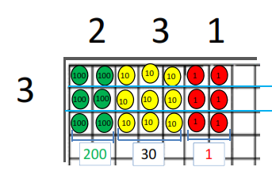  Which of these numbers will divide equally between 2,5,10? How do you know?  Could this number be in the 2x tables? | Mastery  It is correct that 273 × 32 = 8736. Use this fact to work out:  27·3 × 3·2  2·73 × 32 000  873·6 ÷ 0·32  87·36 ÷ 27·3  8736 ÷ 16  4368 ÷ 1·6  Mastery with greater depth  Which calculation is the odd one out?  753 × 1·8 (75·3 × 3) × 6  753 + 753 ÷ 5 × 4  7·53 × 1800  753 × 2 – 753 × 0·2  750 × 1·8 + 3 × 1·8  Explain your reasoning.

Year 5 - Division
Mental Strategies | Written Method
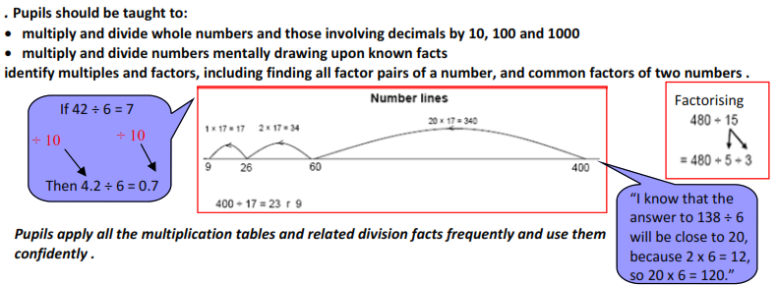 | The language of grouping to be used (see link from fig. 1 in Year 4)  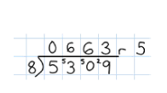  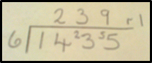  E.g. 1435 ÷ 6 Children begin to practically develop their understanding of how express the remainder as a decimal or a fraction. Ensure practical understanding allows children to work through this (e.g. what could I do with this remaining 1? How could I share this between 6 as well?)  Short division with remainders: Now that pupils are introduced to examples that give rise to remainder answers, division needs to have a real life problem solving context, where pupils consider the meaning of the remainder and how to express it, ie. as a fraction, a decimal, or as a rounded number or value , depending upon the context of the problem.  The answer to 5309 ÷ 8 could be expressed as 663 and five eighths, 663 r 5, as a decimal, or rounded as appropriate to the problem involved.  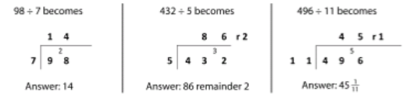  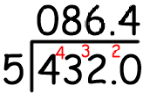
Children’s Representations
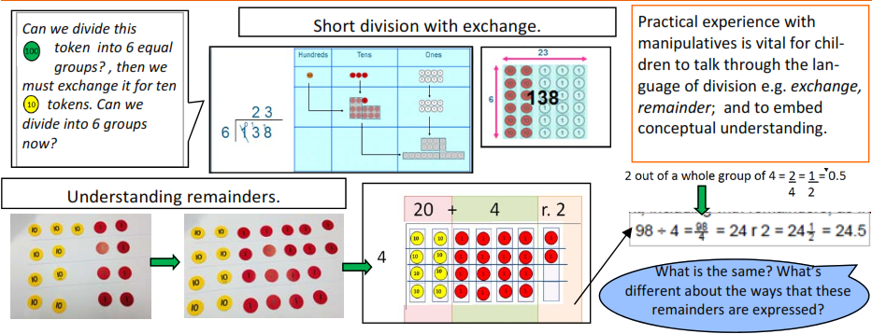
Also used representations of £1, 10p and 1p to model division.

Year 5 - Division
Key Vocabulary
common factors, prime number, prime factors, composite numbers, short division, square number, cube number, inverse, power of, share, share equally, one each, two each, group, equal groups of, lots of, array, divide, divided by, divided into, division, grouping, number line, left, left over, inverse, short division, carry, remainder, multiple, divisible by, factor, inverse, quotient, prime number, prime factors, composite number (non-prime)
Key Questions and Generalisations  The = sign means equality. Take it in turn to change one side of this equation, using multiplication and division, e.g.  Start: 24 = 24  Player 1: 4 x 6 = 24  Player 2: 4 x 6 = 12 x 2  Player 1: 48 ÷ 2 = 12 x 2  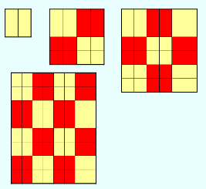  Sometimes, always, never true questions about multiples and divisibility. E.g.:  - If the last two digits of a number are divisible by 4, the number will be divisible by 4.  - If the digital root of a number is 9, the number will be divisible by 9.  - When you square an even number the result will be divisible by 4 (one example of ‘proof’ shown left) | Fractions  Recognise mixed numbers and improper fractions and convert from one form to the other.  Write mathematical statements > 1 as a mixed number.  Pupils connect equivalent fractions > 1 that simplify to integers with division and other fractions > 1 to division with remainders.  Pupils connect multiplication by a fraction to using fractions as operators (fractions of)  Link to division.  Pupils should make connections between percentages, fractions and decimals  Find me ¼ of 16. Find me ¾ of 16. | Mastery  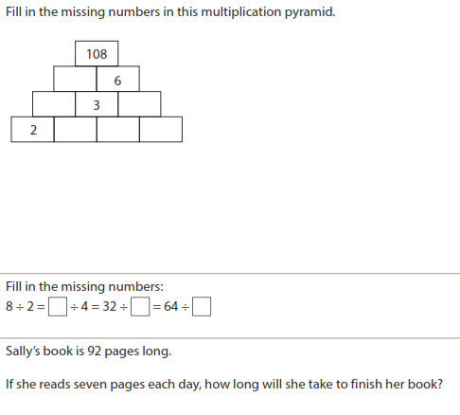

Year 6 - Division
Mental Strategies | Written Method
- Perform mental calculations, including mixed operations and large numbers.  - Identify common factors.  - Identify common multiples.  - Use estimation to check answers to calculations and determine, in the context of a problem, an appropriate degree of accuracy  - Children should count regularly, building on previous work in previous years.  - Children should practice and apply the multiplication facts to 12 x 12  - Pupils should be practising how to express remainders as fractions, decimals or use rounding, depending upon the problem.  - If I divide this number by 5. What will the remainder be? How do you know? | 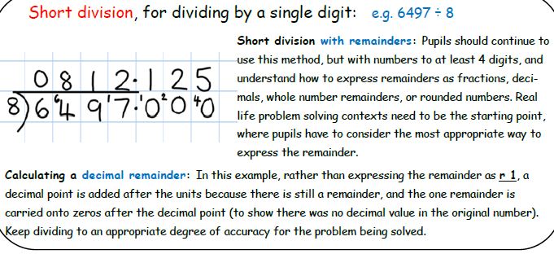  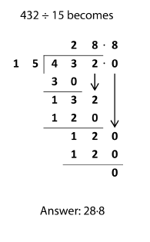  - Divide numbers up to 4 digits by a two digit number and interpret remainders as whole number remainders, fractions or by rounding, as appropriate for the context  - Divide numbers up to 4 digits by a two digit whole number using the formal written method of long division and interpret remainders as whole number remainders, fractions and as a decimal or by rounding, as appropriate for the context.  - Solve problems involving addition, subtraction, multiplication and division.
Children’s Representations
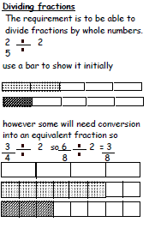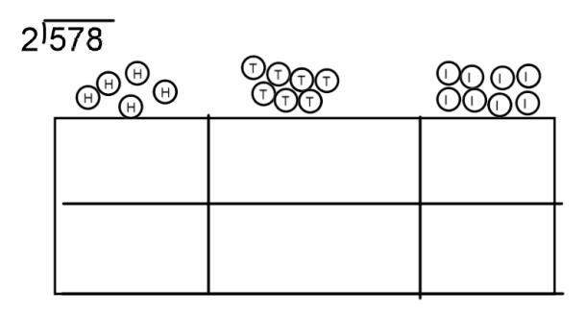
Year 6 - Division
Key Vocabulary
Building on previously taught vocabulary

Key Questions and Generalisations  Order of operations: brackets first, then multiplication and division (left to right) before addition and subtraction (left to right). Children could learn an acrostic such as BODMAS, or could be encouraged to design their own ways of remembering.  Sometimes, always, never true questions about multiples and divisibility. E.g.: If a number is divisible by 3 and 4, it will also be divisible by 12. (also see year 4 and 5, and the hyperlink from the Y5 column)  Using what you know about rules of divisibility, do you think 7919 is a prime number? Explain your answer.  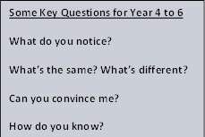 | Fractions  - Divide proper fractions by whole numbers (e.g. ⅓ ÷ 2 = ⅙)  - associate a fraction with division and calculate decimal fraction equivalents (e.g. 0.375) and for a simple fraction (e.g. ⅜)  - identify the value of each digit in numbers given to 3 decimal places and multiply and divide numbers by 10, 100 and 1000, giving answers up to 3 decimal places.  - use written division methods in cases where the answer has up to two decimal places  - recall and use equivalences between simple fractions, decimals and percentages, including in different contexts | Mastery  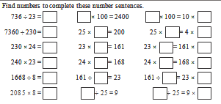  Mastery with Depth  