 | Autumn 1 | Autumn 2 | Spring 1 | Spring 2 | Summer 1 | Summer 2
Year 1 / 2 Year B | Is it better to live in a town or a village? |  | What can castles tell us about the past? |  | What is it like to live by the sea?
Year 1 / 2 Year B | Essential Experiences:  Village / city contrasting localities walk  Making biscuits  Hinduism Theme Day |  | Essential Experiences:  Trip to Lincoln Castle and cathedral  Making Land Art (Andy Goldsworthy)  Church and Cathedral visit  Chinese New Year, Islam Theme Day |  | Essential Experiences:  Trip to the seaside – Hunstanton Sea Life Centre  Outdoor treasure hunt (using maps, pirate themed) Beach visit  Using a map, Following directions, Growing vegetables  Buddhism Theme Day
Year 1 / 2 Year B | Science: Uses and Properties of Everyday Materials (1)  - Distinguish between an object and the material from which it is made.  - Identify and name a variety of everyday materials, including wood, plastic, glass, metal, water, and rock.  - Describe the simple physical properties of a variety of everyday materials.  - Compare and group together a variety of everyday materials on the basis of their simple physical properties. |  | Science: Living things and Their Habitats  - Explore and compare the differences between things that are living, dead, and things that have never been alive.  - Identify that most living things live in habitats to which they are suited and describe how different habitats provide for the basic needs of different kinds of animals and plants, and how they depend on each other.  - Identify and name a variety of plants and animals in their habitats, including microhabitats. Pupils should compare animals in familiar habitats with animals found in less familiar habitats, for example, on the seashore, in woodland, in the ocean, in the rainforest.  - Describe how animals obtain their food from plants and other animals, using the idea of a simple food chain, and identify and name different sources of food. |  | Science: Plants (1) & Seasonal Changes (1)  - identify and name a variety of common wild and garden plants, including deciduous and evergreen trees.  - Identify and describe the basic structure of a variety of common flowering plants, including trees.  - Observe and record changes over time of trees/plants/bulbs/growing plants.  - Observe changes across the four seasons.
Year 1 / 2 Year B | Art / Design & Technology:  Art: Sculpture and 3D : Clay Houses  - Begin to generate ideas from a wider range of stimuli, exploring different media and techniques.  - Experiment in sketchbooks, using drawing to record ideas. Use sketchbooks to help make decisions about what to try out next.  - Further demonstrate increased control with a greater range of media. Use hands and tools with confidence when cutting, shaping and joining paper, card and malleable materials.  - Talk about art they have seen using some appropriate subject vocabulary. Create and critique both figurative and abstract art, recognising some of the techniques used.  - Explain their ideas and opinions about their own and others’ artwork, beginning to recognise the stories and messages within in and showing an understanding of why they may have made it. Begin to talk about how they could improve their own work.  D.T. Mechanisms – Fairground Wheel  - Selecting a suitable linkage system to produce the desired motions.  - Designing a wheel.  - Selecting appropriate materials based on their properties.  - Selecting materials according to their characteristics.  - Following a design brief.  - Evaluating different designs.  - Testing and adapting a design. |  | Art / Design & Technology:  Art: Painting and Mixed Media – Colour Splash  - Name the primary colours.  - Explore coloured materials to mix secondary colours.  - Mix primary colours to make secondary colours.  - Apply paint consistently to their printing materials to achieve a print.  - Use a range of colours when printing.  - Mix five different shades of a secondary colour.  - Decorate their hands using a variety of patterns.  - Mix secondary colours with confidence to paint a plate.  - Describe their finished plates.  D.T. Mechanisms – Making a Moving Monster  - Identify the correct terms for levers, linkages and pivots.  - Analyse popular toys with the correct terminology.  - Create functional linkages that produce the desired input and output motions.  - Design monsters suitable for children, which satisfy most of the design criteria.  - Evaluate their two designs against the design criteria, using this information and the feedback of their peers to choose their best design.  - Select and assemble materials to create their planned monster features.  - Assemble the monster to their linkages without affecting their functionality. |  | Art / Design & Technology:  D.T. Structures: Baby Bear’s Chair  - Generating and communicating ideas using sketching and modelling.  - Learning about different types of structures, found in the natural world and in everyday objects.  - Making a structure according to design criteria.  - Creating joints and structures from paper/card and tape.  - Building a strong and stiff structure by folding paper.  - Exploring the features of structures.  - Comparing the stability of different shapes.  - Testing the strength of their own structures.  - Identifying the weakest part of a structure.  - Evaluating the strength, stiffness and stability of their own structure  Art: Craft and Design: Map it out  - Begin to generate ideas from a wider range of stimuli, exploring different media and techniques.  - Experiment in sketchbooks, using drawing to record ideas.  - Further demonstrate increased control with a greater range of media. Use hands and tools with confidence when cutting, shaping and joining paper, card and malleable materials.  - Talk about art they have seen using some appropriate subject vocabulary.  - Create work from a brief, understanding that artists are sometimes commissioned to create art.  - Create and critique both figurative and abstract art, recognising some of the techniques used.  - Explain their ideas and opinions about their own and others’ artwork, beginning to recognise the stories and messages within in and showing an understanding of why they may have made it. Begin to talk about how they could improve their own work
Year 1 / 2 Year B | Computing:  Y2 Online Safety  - Explain what is meant by online information.  - Recognise what information is safe to be shared online.  - Explain why we need passwords and what makes a strong password.  - Understand that they need to ask permission before sharing content online and explain why.  - Understand that they have the right to deny their permission to information about them being shared online.  - Say who they can ask for help with online worries.  - Use some strategies to work out if online information is reliable or not.  Y2 Computing Systems and Networks 1  - Name some computer peripherals and their function.  - Recognise that buttons cause effects.  - Explain that technology follows instructions.  - Recognise different forms of technology.  - Design an invention which includes inputs and outputs.  - Explain the role of computers in the world around them  Y2 Programming 1  - Decompose a game to predict the algorithms.  - Give a definition for ‘decomposition’.  - Write clear and precise algorithms.  - Create algorithms to solve problems.  - Use loops in their algorithms to make their code more efficient.  - Explain what abstraction is. |  | Computing:  Y2 Computer Systems and Networks 2  - Explain which are the home row keys and how to find them for typing.  - Use the spacebar and backspace correctly.  - Type and make simple alterations to text using buttons on a word processor.  - Search for, import and alter appropriate images for a text document.  - Modify text in a document.  - Use copy and paste to copy text from one document to another.  - Explain what information is safe to be shared online.  Y2 Programming 2  - Explore a new application independently.  - Explain what the blocks on ScratchJr do and use them for a purpose.  - Recognise a loop in coding and why it is useful.  - Use a code to create an animation of an animal moving.  - Use code to follow and create an algorithm.  - Program code to run ‘on tap’.  - Explain the role of the blocks in a program they have created. |  | Computing:  Y2 Creating Media (option 1)  - Create a flip book animation.  - Decompose a story into smaller parts to plan a stop motion animation.  - Create stop motion animations with small changes between images.  Y2 International Space Station  - Describe and explain how astronauts’ survival needs are met aboard the ISS.  - Identify and digitally draw items which fulfil basic human needs when aboard the ISS.  - Read the correct temperature on a thermometer.  - Design a display showing everything that needs to be monitored by sensors on the ISS.  - Create an algorithm that addresses all plants’ needs.  - Explain how space exploration can benefit life on Earth.  - Read data to identify whether a planet might be habitable.
Year 1 / 2 Year B | Geography: UK settlements and physical features  - Identify the human and physical features of Osgodby and London  - Use basic geographical vocab to refer to key physical features, including: beach, cliff, coast, forest, hill, mountain, sea, ocean, river, soil, valley, vegetation, season and weather.  - Use basic geographical vocab to refer to key human features, including: city, town, village, factory, farm, house, office, port, harbour and shop  - Understand that there are different types of settlement  - Locate London on a map  - Distinguish between a city and a capital city  - Understand key features that influenced the location of London as a settlement  - To understand the term ‘population’  - Understand the reasons for London’s diverse population  - To recognise London as a commuter population and understand where commuters travel from  - To understand why London attracts a large number of visitors and investigate the reasons for some of those journeys  - To understand the links between transport and tourism  - To understand the difference between weather and climate  - Recognise ways of recording temperature and rainfall  - Understand the roles of River Thames and parks for London and its population  - Recognise key physical features associated with rivers on maps and photos  - Fieldwork to develop knowledge and understanding of the school and their local area (School - Osgodby ) Use simple fieldwork and observational skills to study the geography of the village and the key human and physical features of its surrounding environment.  - name, locate and identify characteristics of the four countries and capital cities of the United Kingdom and its surrounding seas  Possible Activities  - Use local maps and plans: [Base map of classroom and/or school].  - Classroom and/or school plan/map. (All maps have i) a title, ii) a key iii) a scale [or it is not drawn to scale] and (vi) a direction [eg - North arrow])  - Osgodby – Resources – Google maps/ O.S. maps/ Aerial photos/ Streetview/ Fieldwork.  - On a walk in the local area, children make first hand observations and collect evidence.  - On a base map of Osgodby identify human and physical features. Use a key to show houses, post office, school, chapel, shop [closed – ‘Old Stores’, fields, Green, park].  - Children to take photos of interesting things in the local area and explain what the photos show.  - Use aerial photographs and plan perspectives to recognise landmarks and basic human and physical features; devise a simple map; and use and construct basic symbols in a key  - Osgodby is a village. Discuss why it is.  - The idea of a “Hierarchy of Settlements  - To understand the term ‘population’.  - Reasons for Osgodby’s location – dry site, water nearby, fertile soil/land, religious centre, market?  - Map of the UK. Locate Osgodby and Lincolnshire.  - Tees – Exe line dividing Highland (mainly metamorphic & Igneous rocks) from Lowland (Sedimentary rocks) Britain. Use terms – coast, mountain & river.  - Resource – base map of UK with some features already marked ready to label/put in the key. Eg London, river Thames, Lincolnshire outline, Mountains/Highland – possibly Snowdonia, Lake District, Dartmoor, - Lowland – The Fens, AONB the Lincolnshire Wolds. Forests - Sherwood, Forest of Dean & National Forest.  - London – compare with size with Osgodby. Population.  - Reasons for London’s location: water supply, river (Thames), transport, bridging point, market(s). seat of government, offices (HQs) & transport hub.  - Use world maps, atlases and globes to identify the United Kingdom and its countries. |  | Geography: Global Geography and Weather and Climate  - name, locate and identify characteristics of the four countries and capital cities of the United Kingdom and its surrounding seas  - describe some of the features of a capital city and a focus city (Edinburgh)  - use world maps, atlases and globes to identify the United Kingdom and its countries, as well as the countries, continents and oceans studied at this key stage  - identify seasonal and daily weather patterns in the United Kingdom and the location of hot and cold areas of the world in relation to the Equator and the North and South Poles  - identify the nearest town to their school  - name some typical features of towns  - name and locate the world’s seven continents and five oceans  - To understand that UK weather is seasonal and to name the four seasons  - Name some features of towns and of the countryside  Possible Activities  - Map of the UK with borders drawn in – shade in different colours England, Wales, Scotland and Northern Ireland.  - Name and locate capital cities of the United Kingdom [London, Cardiff, Edinburgh and Belfast].  - Add other big cities – Glasgow, Manchester, Liverpool, Leeds, Sheffield, Birmingham – distinguish between a city and a capital city.  - Mark/shade – North Sea, Irish Sea, English Channel & North Atlantic Ocean.  - [Could mark Lake District, Peak District, - National Parks – countryside, protected areas – also AONBs eg : Lincolnshire Wolds].  - Resource – Atlases. World map/globe – [identify the problems of drawing a 3D globe onto a flat piece of paper)  - Shade the UK on the world map.  - use world maps, atlases and globes to name and locate the world’s seven continents and five oceans.  - Introduce the idea of the world spinning on its axis – on a tilt. Idea of day, night, time zones and seasons in the UK. (Resources – torch, globe (ball) – equinox, summer and winter solstice.  - locate the North and South Poles on a globe and locate the Equator on a globe  - Identify seasonal and daily weather patterns in the UK - temperatures, rainfall and wind speed & direction.  - Use weather station to record rainfall, temperature, wind speed, cloud cover (and pressure)  - Data for local area and from an atlas.  - Line graph showing average monthly temp  - Bar graph showing average monthly rainfall,  - Compare our graph to: (1) Lake District, (2) A hot place (Equatorial forest) (3) a cold place - N or S Pole.  - To describe the climate and environment of the Arctic and Antarctic  - To describe the environment and climate of equatorial areas  - To understand the difference between Weather and Climate. |  | Geography: Coasts  - Identify physical and human features found at seaside resorts  - Describe what a coast is and how people’s lives are connected to it  - Record their own and their families’ coastal experiences  - Recognise features of the UK’s coastline  - Use maps to locate coastal features  - Fieldwork in a coastal area / seaside resort  Possible Activities  - The Yorkshire Coast.  - Resources – coastal photos, maps. Fieldwork to Flamborough and Bridlington? (take note of the the tide times)  - Introduce the idea that waves erode – and create erosional features . . . and the idea that waves carry and deposit material creating depositional features (eg Beach). Use aerial photos and maps.  - Flamborough – Erosion and weathering – but how complex do we get?  - Erosion creates headlands, bays, cliffs, caves, arches, stacks & stumps, and wave-cut platforms.  - Deposition creates beaches, sand dunes, spits (eg Spurn Head)  - Identify physical and human features found at seaside resorts.  - Describe what a coast is and how people’s lives are connected to it. Employment on the coast eg Hull – a port – map/ /Humber Estuary – tourism, fishing, wind turbines, Easington Gas terminal.  - Erosion of Holderness coast leading to loss of homes and jobs.  Recognise features of Yorkshire’s coast (Compare to where the coast was in Roman times).  - Use maps to locate coastal features of the UK’s coastline.  - Fieldwork in a coastal area / seaside resort
Year 1 / 2 Year B | History: The Great Fire of London  - engage in whole class discussion - Pictures drawn by the children, drama / role play, building models, timeline.  - develop empathy and understanding for people of the past through drama  - understand that eyewitness accounts can be unreliable and compare two different versions of the same event.  - know how historical sources (e.g. photos, video, writing) can help us to discover 'the truth' about the past  - understand that lack of photography from certain historical periods can make interpretation unreliable  - Know significant dates related to The Great Fire of London  - Create a factual description that identifies characteristic features of Stuart London  - Explain why certain choices were made when rebuilding after The Great Fire of London  - recognise that there may be different viewpoints about what or who caused The Great Fire of London  - know about the events in the lives of some significant historical figures Samuel Pepys |  | History: Castle Life  - know about significant time periods linked to 'Castles' topic  - know about castle life e.g. lifestyle, battles, contruction. What can we learn from ruins?  - sequence the kings and queens of England  - know about the events in the lives of some significant historical figures  - explain what a biography is and know some features of a biography  - make comparisons about transportation in the past and present  - Children to explain their historical understanding through a range of practical and written activities: whole class discussion, pictures drawn by the children, drama / role play, building models, timelines, annotate photographs, writing stories / fact finding. |  | History: Grace O’Malley  - know about the events in the lives of some significant historical figures – Grace O’Malley
Year 1 / 2 Year B | Religious Education:  Thankfulness / Christian belonging  - Explain what we are thankful for e.g a new school year, autumn and the natural world  - Understand how Christians demonstrate belonging - e.g. through Christening ceremony  - Understand the role of community in the Christian faith – link to belonging to a school community and outward signs of belonging  - Understand the importance of the Christian Harvest Festival as a way of giving thanks for the food we eat  - Know about some harvest festivals from around the world / from different religious traditions (e.g Holi, revise Sukkot)  - Understand the significance of Remembrance as a way of giving thanks for the sacrifice of others.  - Understand the importance of Christmas as a way for Christians to give thanks for the birth of Jesus |  | Religious Education:  Islam: God / Being Human  - Know why the Qur'an is special to Muslims and how this is reflected in the way it is treated  - Understand the Muslim belief of tawhid (oneness of Allah)  - understand why there are 99 names for Allah  - understand how Allah is described in the Qu’ran and why Allah should not be represented pictorially  - know some of the stories about Muhammad and other prophets  - Understand the significance of Muhammad to Muslims  - Retell stories which help Muslims understand the power of Allah e.g. Night of Power, creation story  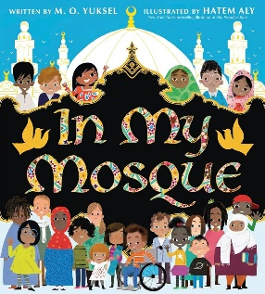 |  | Religious Education:  Islam: Community / Life Journey  - Know the meaning of Iman, Sha'adah, Akhlaq  - Know what Muslims believe about supporting others and supporting the poor  - know how faith is expressed in worship, at home and in the mosque, through the use of significant objects e.g. prayer mats, prayer beads, compass  - Know what happens during key festivals such as Eid-ul-Fitr and Eid-ul-Adha and understand their importance to Muslims  - know what Muslims do to celebrate the birth of a baby and the meanings attached to the actions carried out during the ceremony (Aqiqah) and compare this to the Christian baptism  - know about elements of everyday home life for Muslims e.g. worship at home  - Understand the importance of charity in the Muslim faith  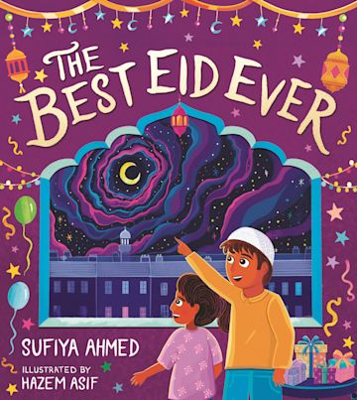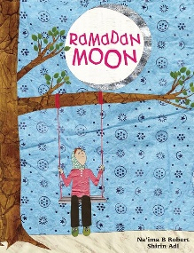
Year 1 / 2 Year B | Music:  Y2 Musical Me  - Clap the rhythm of their name.  - Sing the melody accurately while playing their instrument in time.  - Show a range of emotions using their voices.  - Describe the dynamics and timbre of their pieces.  - Play a known melody from letter notation in the right order, if not with the right rhythms.  - Play a new melody from letter notation in the right order, if not in time.  - Invent a melody, write it down and play it back.  - Select instruments with different timbres.  - Compose and perform a piece using different dynamic levels.  Listening / Appraisal Opportunities: Latin  - Livin’ La Vida Loca by Ricky Martin (Latin/Pop)  - Imperial War March by John Williams (Film)  - It Had Better Be Tonight by Michael Bublé (Latin/Big Band)  - Why Don’t You by Gramophonedzie (Big Band/Dance)  - Oya Como Va by Santana (Latin/Jazz)  Additional Classroom Listening Album:  Abraxas by Santana  Buena Vista Social Club  Y2 On this Island  - Sing, play and follow instructions to perform as a group.  - Describe music using simple musical vocabulary.  - Explore multiple ways of making the same sound.  - Represent the same sound in different ways.  - Describe how they have adapted a sound using musical vocabulary.  - Contribute musically to a final performance.  - Create a piece that clearly represents a particular environment.  - Extend a piece of music so that it represents three distinct environments.  Listening / Appraisal Opportunities: Reggae inspired  - Kingston Town by UB40  - Shine by ASWAD  - IGY by Donald Fagen  - Feel Like Jumping by Marcia Griffiths  - I Can See Clearly Now by Jimmy Cliff |  | Music:  Y1 Timbre and Rhythmic Patterns  - Chant the well-known phrase, “I’ll huff…”  - Make changes to their voices to represent a character.  - Choose a suitable sound to represent a specific point in a story.  - Play a rhythmic pattern along with their spoken words.  - Identify and hold up the correct sign to correspond to some music.  - Play/chant along with the elements of a story with prompting from the teacher.  Listening / Appraisal Opportunities: Musical  - Supercalifragilisticexpialidocious from Mary Poppins  - Pure Imagination from Willy Wonka & The Chocolate Factory soundtrack  - Daydream Believer by The Monkees  - Rainbow Connection from The Muppet Movie  - A Whole New World from Aladdin  Y2 Orchestral Movements  - Make plausible descriptions of the music.  - Identify a few instruments and the sounds of different sections of the orchestra.  - Explain what is happening in the music using language relating to emotion.  - Create a piece of music with some appropriate tempo, dynamic and timbre changes.  - Suggest appropriate musical timbres for each of the characters and tempo changes for the actions.  - Perform confidently using appropriate instrumental sounds.  Listening / Appraisal Opportunities: Pop  - Count On Me by Bruno Mars  - We Go Together (from the Grease soundtrack)  - You Give A Little Love (from Bugsy Malone)  - That's What Friends Are For by Gladys Knight, Stevie Wonder, Dionne Warwick with Elton John  - You've Got A Friend In Me by Randy Newman |  | Music:  Y1 Musical Vocabulary  - Make movements that are appropriate to the pulse and tempo of a piece of music.  - Choose instruments with appropriate timbre to represent sparkling fishes.  - Respond to dynamic changes in a piece of music.  - Create pitches and rhythms.  - Perform a layer of the music within an overall piece.  - Define all the musical terms from this unit.  Listening / Appraisal Opportunities: Classical  - A Song Before Sunrise by Frederick Delius – 20th Century  - The Firebird by Igor Stravinsky – 20th Century  - The Bird by Sergei Prokofiev – 20th Century  - Grand March from Aida by Giuseppe Verdi – Classical  - Bolero by Maurice Ravel – 20th Century  - The Lamb by John Tavener – Contemporary  Y1 Vocal and Body Sounds  - Create movements that match the music, explaining why they are moving in that way.  - Identify descriptive sounds within the music.  - Recreate and then adapt descriptive sounds heard using their voice or body.  - Make appropriate instrument choices to represent a descriptive sound.  - Control instruments and voices to make both quiet and loud sounds.  - Follow simple instructions during a group performance.  - Create their own graphic score and play from it.  - Make more than one sound on their instrument and with their voice.  Listening / Appraisal Opportunities: instrumental  - Peer Gynt Suite: Anitras  - Dance by Edvard Grieg – Romantic  - Brandenburg Concerto No 1 by Johann Sebastian Bach – Baroque  - From The Diary Of A Fly by Béla Bartók – 20th Century  - Fantasia On Greensleeves by Ralph Vaughn Williams – 20th century  - Dance of The Sugar Plum Fairy by Pytor Tchaikovsky – Romantic  - The Robots (Die Roboter) by Kraftwerk – Contemporary
Year 1 / 2 Year B | Physical Education:  Invasion games (e.g. basketball, netball, football)  - Master basic movements including running, jumping, throwing and catching, as well as developing balance, agility and co-ordination, and begin to apply these in a range of activities  - Participate in team games, developing simple tactics for attacking and defending  Dance  - Perform dances using simple movement patterns  Gymnastics  - Master basic movements including running, jumping, throwing and catching, as well as developing balance, agility and co-ordination, and begin to apply these in a range of activities |  | Physical Education:  Swimming  Swim competently, confidently and proficiently over a distance of at least 25 metres. Use a range of strokes effectively Perform safe self-rescue in different water-based situations  Team Games  Participate in team games, developing simple tactics for attacking and defending Master basic movements including running, jumping, throwing and catching, as well as developing balance, agility and co-ordination, and begin to apply these in a range of activities  Athletics  Master basic movements including running, jumping, throwing and catching, as well as developing balance, agility and co-ordination, and begin to apply these in a range of activities |  | Physical Education:  Striking and fielding (e.g. cricket/rounders)  - Master basic movements including running, jumping, throwing and catching, as well as developing balance, agility and co-ordination, and begin to apply these in a range of activities  - Participate in team games, developing simple tactics for attacking and defending  Athletics  - Master basic movements including running, jumping, throwing and catching, as well as developing balance, agility and co-ordination, and begin to apply these in a range of activities
Year 1 / 2 Year B | P.S.H.E. / R.S.E.  Being Me in My World (Y2)  Celebrating Difference (Y2)  - Know there are stereotypes about boys and girls  - Know that it is OK not to conform to gender stereotypes  - Know it is good to be yourself  - Know that sometimes people get bullied because of difference  - Know the difference between right and wrong and the role that choice has to play in this  - Know that friends can be different and still be friends  - Know where to get help if being bullied  - Know the difference between a one-off incident and bullying  - Understand that boys and girls can be similar in lots of ways and that is OK  - Understand that boys and girls can be different in lots of ways and that is OK  - Explain how being bullied can make someone feel  - Can choose to be kind to someone who is being bullied  - Know how to stand up for themselves when they need to  - Recognise that they shouldn’t judge people because they are different  - Understand that everyone’s differences make them special and unique  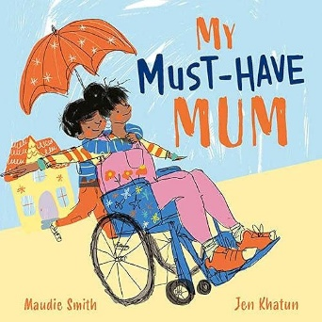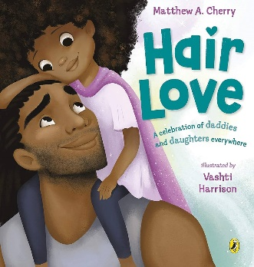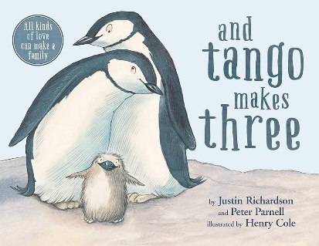 |  | P.S.H.E. / R.S.E.  Dreams and Goals (Y2)  - Know how to choose a realistic goal and think about how to achieve it  - Know that it is important to persevere  - Know how to recognise what working together well looks like  - Know what good group working looks like  - Know how to share success with other people  - Be able to describe their own achievements and the feelings linked to this  - Recognise their own strengths as a learner  - Recognise how working with others can be helpful  - Be able to work effectively with a partner  - Be able to choose a partner with whom they work well  - Be able to work as part of a group  - Recognise how it feels to be part of a group that succeeds and store this feeling  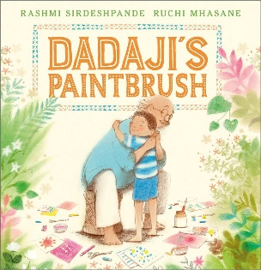  Healthy Me (Y2)  - Know what their body needs to stay healthy  - Know what relaxed means  - Know what makes them feel relaxed / stressed  - Know how medicines work in their bodies  - Know that it is important to use medicines safely  - Know how to make some healthy snacks  - Know why healthy snacks are good for their bodies  - Know which foods give their bodies energy  - Desire to make healthy lifestyle choices  - Identify when a feeling is weak and when a feeling is strong  - Feel positive about caring for their bodies and keeping it healthy  - Have a healthy relationship with food  - Express how it feels to share healthy food with their friends |  | P.S.H.E. / R.S.E.  Relationships (Y2)  - Know that everyone’s family is different  - Know that families function well when there is trust, respect, care, love and co-operation  - Know that there are lots of forms of physical contact within a family  - Know how to stay stop if someone is hurting them  - Know some reasons why friends have conflicts  - Know that friendships have ups and downs and sometimes change with time  - Know how to use the Mending Friendships or Solve-it-together problem-solving methods  - Know there are good secrets and worry secrets and why it is important to share worry  secrets  - Know what trust is  - Can identify the different roles and responsibilities in their family  - Can recognise the value that families can bring  - Can recognise and talk about the types of physical contact that is acceptable or unacceptable  - Can use positive problem-solving techniques (Mending Friendships or Solve-it-together) to  - resolve a friendship conflict  - Can identify the negative feelings associated with keeping a worry secret  - Can identify the feelings associated with trust  - Can identify who they trust in their own relationships  - Can give and receive compliments  - Can say who they would go to for help if they were worried or scared  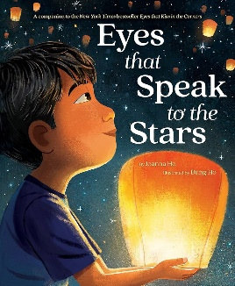  Changing Me (Y2)  - Know that life cycles exist in nature  - Know that aging is a natural process including old-age  - Know that some changes are out of an individual’s control  - Know how their bodies have changed from when they were a baby and that they will continue to change as they age  - Know the physical differences between male and female bodies  - Know the correct names for private body parts  - Know that private body parts are special and that no one has the right to hurt these  - Know who to ask for help if they are worried or frightened  - Know there are different types of touch and that some are acceptable and some are unacceptable  - Can appreciate that changes will happen and that some can be controlled and others not  - Be able to express how they feel about changes  - Show appreciation for people who are older  - Can recognise the independence and responsibilities they have now compared to being a baby or toddler  - Can say what greater responsibilities and freedoms they may have in the future  - Can say who they would go to for help if worried or scared  - Can say what types of touch they find comfortable/ uncomfortable  - Be able to confidently ask someone to stop if they are being hurt or frightened  - Can say what they are looking forward to in the next year  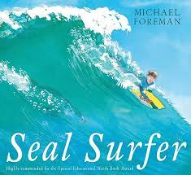
  - Identifying hopes and fears for the year ahead
  - Understand the rights and responsibilities of class members
  - Know that it is important to listen to other people
  - Understand that their own views are valuable
  - Know about rewards and consequences and that these stem from choices
  - Know that positive choices impact positively on self-learning and the learning of others
  - Recognise own feelings and know when and where to get help
  - Know how to make their class a safe and fair place
  - Show good listening skills
  - Recognise the feeling of being worried
  - Be able to work cooperatively

