PROMOTING
BRITISH
VALUES

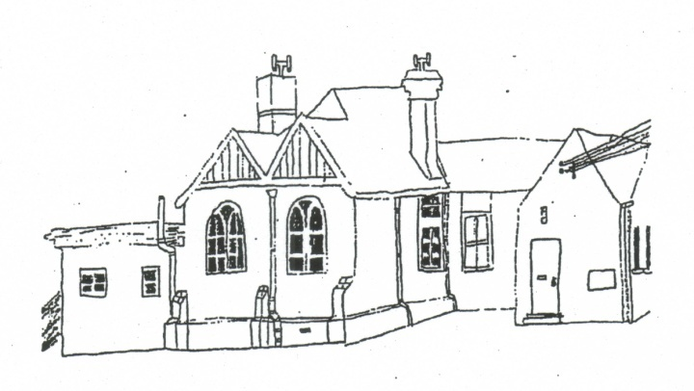

February 2019

OSGODBY PRIMARY SCHOOL

Promoting British Values
The Department for Education state that there is a need “to create and enforce a clear and rigorous expectation on all schools to promote the fundamental British values of democracy, the rule of law, individual liberty and mutual respect and tolerance of those with different faiths and beliefs.” The government set out its definition of British values in the 2011 Prevent Strategy and these values were reiterated by the Prime Minister in 2014. At Osgodby Primary School these values are promoted and reinforced regularly through our school mission statement and our curriculum and enrichment activities in the following ways.
Democracy
- Pupils are always listened to by adults and are taught to listen carefully and with concern to each other, respecting the rights of every individual
- The elections of the School Council members and House Captains are based solely on pupil votes, reflecting our British electoral system.
- We have an elected School Council, Sports Council and Eco Council. This is used as an opportunity to promote and teach about democracy in action and the electoral process.
- Questionnaires and surveys provide pupils with the opportunity to air their opinions and ideas and voices heard.
- We encourage volunteering in school. This includes roles and responsibilities eg the School Council, Sports Council, librarians, Y6 responsibilities and also raising money for local and national charities.
- The beginnings of democracy are taught through historical research of the Ancient Greece civilisation.
- Democracy is also promoted through additional PSHE lessons and assemblies.
- Children are taught to respect their rights and the rights of others.
The rule of law
- Our 5 Golden Rules are deeply embedded in our work every day and help the children to understand the behaviour that we expect here at Osgodby Primary School. We talk about being the best that we can be across a wide range of times and places at school. Whether it’s persevering in a lesson or being a caring class mate the children know the behaviours that fit with our promise.
- Each class also discusses and sets its own rules that are clearly understood by all and seen to be necessary to ensure that every class member is able to learn in a safe and ordered environment.
- We have high expectations about pupil conduct and this is reflected in our Behaviour Policy. Housepoints (gold coins) are awarded for exhibiting good and caring behaviour and is recognised in celebration assemblies.
- The importance of Laws, whether they be those that govern the class, the school, or the country, are consistently reinforced when dealing with behaviour and through school assemblies. Pupils are taught the value and reasons behind laws, that they govern and protect us, the responsibilities that this involves and the consequences when laws are broken.
- Through our school assemblies, circle time and PSHE children are taught how to earn trust and respect and are supported to develop a strong sense of morality; knowing right from wrong and doing the right thing even when it’s difficult.
- Staff work closely with pupils who need additional support managing their feelings and behaviour.

Individual liberty
- Children are taught and learn to respect their rights and the rights of others.
- Within school, pupils are actively encouraged to make choices, knowing that they are in a safe and supportive environment. As a school we educate and provide boundaries for our pupils to make choices safely, through the provision of a safe environment. Our pupils are encouraged to know, understand and exercise their rights and personal freedoms and are advised how to exercise these safely; examples of this can be clearly seen in our e-safety and PSHE lessons. Whether it is through choice of challenge; of how they record; of participation in our numerous extra- curricular activities; our pupils are given opportunities to make choices.
- Children are taught how to keep themselves safe, including online. This is done through computing lessons, assemblies and on Safer Internet Day (SID) as well as through the PSHE curriculum.

Mutual respect
- We have high expectations about pupil conduct and this is reflected in our Behaviour Policy.
- Through our school’s promise, PSHE and circle time children are taught to respect each other, to be cooperative and collaborative, be supportive and to look for similarities while being understanding of differences.
- A strength of our school is pupils understanding and support for other pupils with additional specific special needs. The pupils know and understand that it is expected and imperative that respect is shown to everyone, whatever differences we may have.
Tolerance of different faiths and beliefs
- Knowledge understanding and tolerance of different faiths and beliefs is promoted through the Syllabus for Religious Education. Children learn about different religions, their beliefs, places of worship and festivals eg Chinese New Year. The children’s work on this subject or whole school learning in assemblies is often displayed in the classrooms or around the school. Through this our pupils gain an enhanced understanding of their place in a culturally diverse society.
- Whole school assemblies also mark and celebrate significant religious festivals such as Christmas, Sukkot, Ramadan and Diwali.
- Visits are made by local religious leaders and children have the opportunity to visit places of worship.
- Displays and library books promote understand

